**Heart Problems Prediction**

**A PROJECT REPORT**

#### Submitted by

**Aji Santhosh Kumar Nair (19BCS1903)**

**Keshav Mishra (19BCS1887)**

**Sahil Lamba (19BCS1922)**

**Sahil Mallick (19BCS1073)**

***in partial fulfillment for the award of the degree of***

## BACHELOR OF ENGINEERING

**IN**

**COMPUTER SCIENCE & ENGINEERING**



**Chandigarh University**

DECEMBER, 2022



## BONAFIDE CERTIFICATE

Certified that this project report **“Heart Problems Prediction”** is the bonafide work of **“**Aji Santhosh Kumar Nair (19BCS1903), Keshav Mishra (19BCS1887), Sahil Lamba (19BCS1922) & Sahil Mallick (19BCS1073)**”** who carried out the project work under my/our supervision.

**SIGNATURE SIGNATURE**

Dr. Navpreet Kaur Walia Er. Rishi Pal

##### **HEAD OF THE DEPARTMENT** SUPERVISOR

**Associate Professor**

Department of Computer Science Department of Computer Science

& Engineering & Engineering

Submitted for the project viva-voce examination held on \_

INTERNAL EXAMINER EXTERNAL EXAMINER

## TABLE OF CONTENTS

List of Figures i

List of Tables ii

Abstract ..iii

**Graphical Abstract……………………………………………………………………………………………v**

Abbreviations vi

**Symbols…………………………………………………………………………….…………………………vi**

Chapter 1. Introduction….…………………………………..……………….……………………………1-3

1. Need Identification…...........................................…………….…...………………………………………..1
2. Identification of Problem…………...……………………………………….………………………….2
3. Identification of Task…..…………………………..……………….……….………………………….2
4. Timeline…...………………………………………………………………….………………………...3
5. Organization of Report…………………………………………………………………………….…...3

### Chapter 2. Background Study………………………………………………………………………………4-8

2.1**.** Timeline of the reported problem……………………………………………………………………...4

### 2.2. Proposed Solutions……………………………………………………..….…………………………..6

2.3. Bibliometric Analysis………………………………………………………………………………….7

2.4. Review Summary…………………………………………………………..………………………….7

2.5. Problem Definition…………………………………………………………………………………….8

2.6. Objectives……………………………………………………………………………………………...8

**Chapter 3. Proces…………………………………………………………………………………………...9-38**

3.1. Evaluation & Selection of Specifications/Features…………………………………………………….9

3.1.1. Machine Learning………………………………………………………..………………………...9

3.1.2. Classification Algorithms…………………………………………………………………………11

3.2. Design Constraints………………………………………………………...…………………………...21

3.2.1. Hardware Requirement……………………………………..………..…………………………….21

3.2.2. Software Requirement…………………………………………..………………………………....21

3.2.3. Technologies……………………………………………………….………………………………22

3.3. Analysis and Feature finalization subject to constraints…………………………………………………22

3.4. Design Flow………………………………………………………..……….……………………………22

3.5. Design Selection………………………………………………………….….………………………….24

3.6. Implementation plan……………………………..……………………….……………………………...25

3.6.1. Data Wrangling………………………………...…………………….….………………………….25

3.6.2. Exploratory Data Analysis……………………………………...……..……………………………27

3.6.3. Model Training……………………………………………………………………………………..33

3.6.4. Finding Feature Importance.………………………………………………………………………..36

### Chapter 4. Results Analysis and Validation…………………….……………………………………....39-45

4.1. Implementation of solution……………………………………………………………………….……39

4.1.1. Analysis…………………………………………………………………………………………..39

4.1.2. Results…………………………………………………………………………………………….41

4.1.3. Testing…………………………………………………………………………………………….42

**Chapter 5. Conclusion and Future Work…………………….…………….……….…………………………..46**

5.1. Conclusion……………………………………………….…………………..….…………………………..46

5.2. Future Work…………………………………………….…………………………………………………..46

### References…………..............................................................................................……………………………..47

**Appendix………………………………………………………………………………………………………51**

**User Manuel…………………………………………………………………………………………………..54**

**List of Figures**

**Fig 1.1. Grant Chart…………………………………………………………………………………………3**

**Fig 3.1. Classification of Machine Learning………………………………………………………………….9**

**Fig 3.2. Logistic Regression…………………………………………………………………………………12**

**Fig 3.3. Support Vector Machine…………………………………………………………………………...19**

**Fig 3.4. KNN Classifier……………………………………………………………………………………..20**

**Fig 3.5. System Architecture 1……………………………………………………………………………...23**

**Fig 3.6. System Architecture 2……………………………………………………………………………...23**

**Fig 3.7. Design Flow of the System………….………………………………………………………………24**

**Fig 3.8. Block Diagram of the System………………………………………………………………………25**

**Fig 3.9. Correlation Matrix…………………………………………………………………………………28**

**Fig 3.10. Pairplots…………………………………………………………………………………………...29**

**Fig 3.11. ST depression (induced by exercise relative to rest) vs. Heart Disease……………………………..30**

**Fig 3.12. Thalach Level vs. Heart Disease…………………………………………………………………...31**

**Fig 3.13. ST depression Level vs. Heart Disease….…………………………………………………………31**

**Fig 3.14. Feature Importance Graph….……………………………………………………………………37**

**Fig 4.1. Accuracy Scores……………………………………………………………………………………40**

**Fig 4.2. Distribution of age………………………………………………………………………………….43**

**Fig 4.3. Distribution of sex………………………………………………………………………………….44**

**Fig 4.4. Distribution of chest pain…………………………………………………………………………...44**

**Fig 4.5. Distribution of chest trestbps……………………………………………………………………….45**

**Fig 4.5. Distribution of chest Exang………………………………………………………………………....45**

**List of Tables**

**Table 1.1. Distribution Of Task………………………………………………………….…………2**

**Table 3.1. Attributes of the Heart disease dataset………………………………………………..22**

**Table 3.2. Dataset…………………………………………………………………………………...26**

**Table 3.3. Summary of the Dataset………………………………………………………………..27**

**Table 3.4. Positive Heart Disease Patients………………………………………………………...32**

**Table 3.5. Negative Heart Disease Patients……………………………………………………….32**

**Table 4.1. Confusion Matrix……………………………………………………………………….39**

## ABSTRACT

Heart is the most essential or crucial portion of our body. Heart is used to maintain and conjugate blood in our body. There are a lot of cases in the world related to heart diseases. People are leading to death due to heart disease. Various symptoms like chest pain, fasting of heartbeat and so on are mentioned. The health care industries found a large amount of data. This paper gives the idea of predicting heart disease using machine learning algorithms.

One of the most challenging issues in the medical world is the prediction of heart disease. According to recent data, every minute a person dies from heart disease. Processing a vast amount of data in the health care industry requires machine learning. Since predicting heart is a complex undertaking, it is necessary to automate the process in order to reduce risks and warn the patient well in advance. In this project, we have researched about different models for heart disease prediction through various heart attributes of patient and detect impending heart disease using Python and Machine learning .

Machine learning algorithms like Naive Bayes, Decision Tree, Support Vector Machine, K-Nearest Neighbors, Logistic Regression, Random Forest and XGBoost on the dataset available publicly on Kaggle Website, further evaluating the results using confusion matrix and Feature Score. It is found that Random Forest algorithm and also the logistic regression both of these algorithm gives the most accurate results among all of the algorithms mentioned above .But , between these two the Random Foreset give the ideal accuracy of 80% when compared to other algorithms for heart disease prediction that is the main reason why we are more focused on this algorithm and why we are using it in our project and we are hoping that it will provide us the accuracy in the results that we desire.

Accordingly the more accuracte algorithm can be developed and the researchers accelerating their research works to develop software with thehelp of machine learning algorithms which can help doctors to decide both prediction and diagnosing of heart disease. The main objective of this research project is to predict the heart disease of a patient using machine learning algorithms. So that we can avoid the risk to the paitents life timely .

**सार**

हृदय हमारे शरीर का सबसे आवश्यक या महत्वपूर्ण अंग है। हमारे शरीर में रक्त को बनाए रखने और संयुग्मित करने के लिए हृदय का उपयोग किया जाता है। दुनिया में दिल की बीमारियों से जुड़े कई मामले सामने आते हैं। लोग हृदय रोग के कारण मौत की ओर बढ़ रहे हैं। सीने में दर्द, दिल की धड़कन का तेज़ होना आदि जैसे विभिन्न लक्षणों का उल्लेख किया गया है। स्वास्थ्य देखभाल उद्योगों को बड़ी मात्रा में डेटा मिला। यह पेपर मशीन लर्निंग एल्गोरिदम का उपयोग करके हृदय रोग की भविष्यवाणी करने का विचार देता है।

चिकित्सा जगत में सबसे चुनौतीपूर्ण मुद्दों में से एक हृदय रोग की भविष्यवाणी है। हाल के आंकड़ों के अनुसार, हर मिनट एक व्यक्ति हृदय रोग से मरता है। स्वास्थ्य देखभाल उद्योग में बड़ी मात्रा में डेटा को संसाधित करने के लिए मशीन लर्निंग की आवश्यकता होती है। चूंकि हृदय की भविष्यवाणी करना एक जटिल उपक्रम है, जोखिम को कम करने और रोगी को पहले से अच्छी तरह से चेतावनी देने के लिए प्रक्रिया को स्वचालित करना आवश्यक है। इस परियोजना में, हमने रोगी के हृदय की विभिन्न विशेषताओं के माध्यम से हृदय रोग की भविष्यवाणी के लिए विभिन्न मॉडलों के बारे में शोध किया है और पायथन और मशीन लर्निंग का उपयोग करके आसन्न हृदय रोग का पता लगाया है।

मशीन लर्निंग एल्गोरिदम जैसे Naive Bayes, Decision Tree, सपोर्ट वेक्टर मशीन, K-नियरेस्ट नेबर्स, लॉजिस्टिक रिग्रेशन, रैंडम फ़ॉरेस्ट और XGBoost डेटासेट पर सार्वजनिक रूप से कागले वेबसाइट पर उपलब्ध हैं, भ्रम मैट्रिक्स और फ़ीचर स्कोर का उपयोग करके परिणामों का मूल्यांकन करते हैं। यह पाया गया है कि रैंडम फ़ॉरेस्ट एल्गोरिथम और लॉजिस्टिक रिग्रेशन ये दोनों एल्गोरिथम उपरोक्त सभी एल्गोरिदम के बीच सबसे सटीक परिणाम देते हैं। लेकिन, इन दोनों के बीच रैंडम फ़ॉरेस्ट अन्य एल्गोरिदम की तुलना में 80% की आदर्श सटीकता देता है। हृदय रोग की भविष्यवाणी यही मुख्य कारण है कि हम इस एल्गोरिथम पर अधिक ध्यान केंद्रित कर रहे हैं और हम इसे अपनी परियोजना में क्यों उपयोग कर रहे हैं और हम उम्मीद कर रहे हैं कि यह हमें वांछित परिणामों में सटीकता प्रदान करेगा।

तदनुसार अधिक सटीक एल्गोरिदम विकसित किया जा सकता है और शोधकर्ता मशीन लर्निंग एल्गोरिदम की मदद से सॉफ्टवेयर विकसित करने के लिए अपने शोध कार्यों को गति दे रहे हैं जो डॉक्टरों को हृदय रोग की भविष्यवाणी और निदान दोनों का निर्णय लेने में मदद कर सकते हैं। इस शोध परियोजना का मुख्य उद्देश्य मशीन लर्निंग एल्गोरिदम का उपयोग करके रोगी के हृदय रोग की भविष्यवाणी करना है। ताकि हम समय रहते मरीजों की जान को होने वाले जोखिम से बच सकें .

## **GRAPHICAL** ABSTRACT

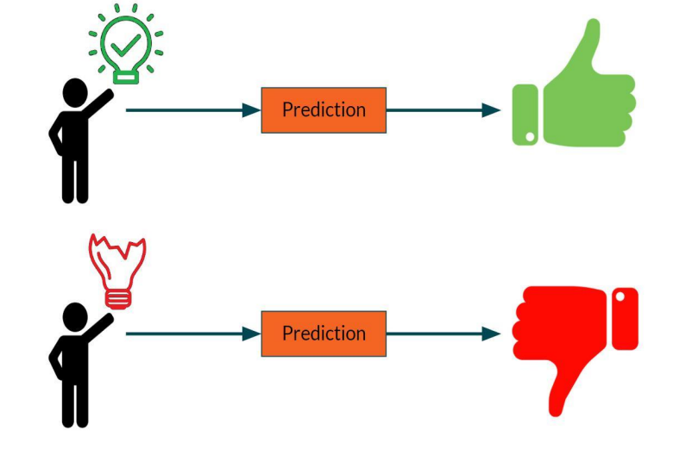

**ABBREVIATIONS**

|  |  |
| --- | --- |
| ML | Machine learning |
| WHO | World Health Organization |
| KNN | K-Nearest Neighbors |
| SVM | Support Vector Machine |
| XG | Extreme Gradient |

**SYMOBLS**

|  |  |
| --- | --- |
| TP | Number of people with heart diseases. |
| TN | Number of people with heart diseases and no heart diseases. |
| FP | Number of people with no heart diseases. |
| FN | Number of people with no heart diseases and with heart diseases. |
| f(x) | Output between the 0 and 1 value. |
| e | Base of the natural logarithm. |
| x | Input to the function |

**CHAPTER 1:**

**INTRODUCTION**

One of the leading causes of morbidity and mortality among the global population is heart disease. The World Health Organization estimates that heart disease causes 12 million deaths worldwide each year. In the last years ago, the prevalence of heart disease has been rising quickly throughout the world. Numerous studies have been carried out in an effort to identify the most important risk factors for heart disease and to precisely estimate the overall risk. Heart disease is also referred to as a silent killer because it causes a person to pass away without any evident signs. Early detection of heart disease is critical in making decisions about lifestyle adjustments in high-risk patients, which minimizes complications.

### Need Identification:

Imagine you've just started working at a hospital where an alarming number of patients are reporting symptoms related to heart diseases. A cardiologist takes vital signs and gives you the information you need to perform data analysis and predict whether certain patients have heart disease. Your job is to determine whether a patient should be diagnosed with heart disease based on the data provided to you. So, you built a machine learning system that recognizes who has symptoms of heart disease, such as chest pain or high blood pressure, and can assist in diagnosing disease with fewer medical tests and more effective treatments, so that they can be treated appropriately.

Machine learning has been proven to be successful in assisting in decision making and prediction from the huge amount of data provided by the health care sector. This project aims to predict future heart problems by analyzing patient data and determining whether or not they have heart disease using a machine-learning algorithm. Machine Learning techniques can be extremely useful in this regard. Even though heart disease can manifest itself in various ways, there is a common set of key risk factors that impact whether someone is at risk for heart disease or not.

Machine Learning techniques can be extremely useful in this regard . If they can be implemented correctly by using the right practices the life’s of countless needy patients can be saved and that is our main purpose . Machine learning has been proven to be successful in assisting in decision making and prediction . We may say that this technique can be extremely well fitted to predict heart disease as it gathers data from numerous sources, classifies it under appropriate headings, and then analyses it to extract the needed data .

### Identification of Problem:

Detecting the heart disease is a difficult task. There are technologies that can be used to predict heart disease, but they are either too expensive or too inefficient to quantify the risk of heart disease in humans. Early identification of heart problems has been shown to reduce mortality and overall consequences. However, it is not possible to precisely monitor patients every day in all circumstances, and 24 hour observation by a doctor is not available because that takes more intelligence, time, and skill. We may use multiple machine learning algorithms to evaluate data for hidden patterns in today's environment because we have a lot of data. Hidden patterns in medical data can be used for health diagnosis.

### Identification of Task:

The task is to offer a heart disease prediction model for predicting the presence of heart disease. Furthermore, the purpose of is to find the best classification algorithm for detecting the likelihood of heart disease in a patient. This work is justified by doing a comparison investigation and analysis with seven classification algorithms, namely Naive Bayes, Decision Tree, Support Vector Machine, K-Nearest Neighbors, Logistic Regression, Random Forest and XGBoost, at various degrees of evaluation. Although these are typical machine learning methods, heart disease prediction is a critical task that requires the best possible accuracy. As a result, the seven algorithms are examined at various levels and with various sorts of evaluation procedures. This will allow researchers and medical practitioners to develop a better method.

|  |  |  |
| --- | --- | --- |
| **S. No.** | **UID** | **Role in Project Development And Implementation** |
| 1. | 19BCS1903 | Collection of dataset and data processing. |
| 2. | 19BCS1887 | Analysis and feature finalization. |
| 3. | 19BCS1922 | Exploratory Data Analysis and Design Selection. |
| 4. | 19BCS1073 | Implementation of classification algorithms and Feature Selection. |

**Table 1.1: Distribution Of Task**

### Timeline:

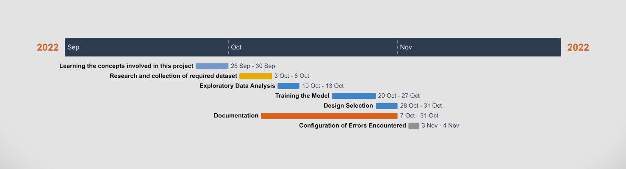

**Fig 1.1. Grant Chart**

**1.5. Organization of the Report:**

The following chapters will give an elaborate description of the project :-

* **Chapter 1:** This section effectively represents the first stage of the project development life cycle, during which we prove the problem's existence by data and documentation, or show that someone requires and wants to find a solution. We outlined the multiple problems that this project would address, and the advantages of creating such a prediction model.
* **Chapter 2:** This section includes the literature review of the proposed project, in which we firstly note the work that has already been done in this field and then discuss the modifications
* **Chapter 3:** The main objective of the application is outlined in this part, which also wraps up the design and implementation phases. We conducted a thorough examination of the elements that we considered were the most important and regularly used by various developers before coming up with the list of features that we would like to build and include in the project.
* **Chapter 4:** During this phase, we evaluate the final application of the project using other references and literature reviews to help us understand that, in addition to accuracy, there are some other factors that provide information about our visualizer.
* **Chapter 5:** This phase primarily aids in providing an overview of the entire process as well as trying to define the best possible results we obtained after carrying out all necessary development and what results we obtained throughout the entire process. We also provide future work that we can carry out what we are lacking currently due to potential causes.

**CHAPTER 2**

**BACKGROUND STUDY**

With the advancement of medical science and machine learning, different experiments and researches have been conducted in recent years, resulting in the publication of major papers. We have discussed the contribution of some of these studies and previously proposed solutions in this section.

**2.1. Timeline of the reported problem:**

Following are some previously published studies in this field :-

In June 2016, Sonam Nikhar & A. M. Karandikar proposed a paper “Prediction of Heart Disease Using Machine Learning Algorithms”.

Their research gives point to point explanation of Naïve Bayes and decision tree classifier that are used especially in the prediction of Heart Disease. Some analysis has been led to think about the execution of prescient data mining strategy on the same dataset, and the result decided that Decision Tree has highest accuracy than Bayesian classifier.

In December 2016, [Kanak Saxena](https://www.researchgate.net/scientific-contributions/Kanak-Saxena-2195633596), [Richa Sharma](https://www.researchgate.net/scientific-contributions/Richa-Sharma-2105882485) & Purushottam proposed a paper “Efficient Heart Disease Prediction System” using hill climbing and decision tree algorithms.

They used Cleveland dataset and preprocessing of data is performed before using classification algorithms. The Knowledge Extraction is done based on Evolutionary Learning (KEEL), an opensource data mining tool that fills the missing values in the data set. A decision tree follows top-down order. For each actual node selected by hill-climbing algorithm a node is selected by a test at each level. The parameters and their values used are confidence. Its minimum confidence value is 0.25. The accuracy of the system is about 86.7%.

In February 2018, Aakash Chauhan & [Aditya Jain](https://www.semanticscholar.org/author/Aditya-Jain/2110543127) proposed “Heart Disease Prediction using Evolutionary Rule Learning”.

Data is directly retrieved from electronic records that reduce the manual tasks. The amount of services are decreased and shown major number of rules helps within the best prediction of heart disease. Frequent pattern growth association mining is performed on patient’s dataset to generate strong association.

In March 2018, Aditi Gavhane, [Gouthami Kokkula](https://www.researchgate.net/scientific-contributions/Gouthami-Kokkula-2129669427) & [Isha Pandya](https://www.researchgate.net/scientific-contributions/Isha-Pandya-2148676566) proposed a paper “Prediction of Heart Disease Using Machine Learning”.

In their research, training and testing of dataset is performed by using neural network algorithm multi-layer perceptron. In this algorithm there will be one input layer and one output layer and one or more layers are hidden layers between these two input and output layers. Through hidden layers each input node is connected to output layer. This connection is assigned with some random weights. The other input is called bias which is assigned with weight based on requirement the connection between the nodes can be feed forwarded or feedback.

In April 2018, Abhay Kishore & Ajay Kumar proposed “Heart Attack Prediction Using Deep Learning”.

They made their heart attack prediction system by using Deep learning techniques and to predict the probable aspects of heart related infections of the patient Recurrent Neural System is used. This model uses deep learning and data mining to give the best precise model and least blunders. This paper acts as strong reference model for another type of heart attack prediction models.

In April 2019, Santhana Krishnan. J & [Geetha. S](https://www.researchgate.net/scientific-contributions/Geetha-S-2158886873) proposed a paper “Prediction of Heart Disease Using Machine Learning Algorithms” using decision tree and Naive Bayes algorithm for prediction of heart disease.

In decision tree algorithm the tree is built using certain conditions which gives True or False decisions. The algorithms like SVM, KNN are results based on vertical or horizontal split conditions depends on dependent variables. But decision tree for a tree like structure having root node, leaves and branches base on the decision made in each of tree Decision tree also help in the understating the importance of the attributes in the dataset. They have also used Cleveland data set. Dataset splits in 70% training and 30% testing by using some methods. This algorithm gives 91% accuracy. The second algorithm is Naive Bayes, which is used for classification. It can handle complicated, nonlinear, dependent data so it is found suitable for heart disease dataset as this dataset is also complicated, dependent and nonlinear in nature. This algorithm gives an 87% accuracy.

In June 2019, Pavan Kumar & Avinash Golande proposed “Heart Disease Prediction Using Effective Machine Learning Techniques”.

In their research, few data mining techniques are used that support the doctors to differentiate the heart disease. Usually utilized methodologies are k-nearest neighbour, Decision tree and Naïve Bayes. Other unique characterization-based strategies utilized are packing calculation, Part thickness, consecutive negligible streamlining and neural systems, straight Kernel self arranging guide and SVM (Bolster Vector Machine).

In July 2019, Senthil Kumar Mohan, [Chandra Segar Thirumalai](https://www.researchgate.net/profile/Chandra-Segar-Thirumalai) & [Gautam Srivastava](https://www.researchgate.net/profile/Gautam-Srivastava) proposed a paper “Effective Heart Disease Prediction Using Hybrid Machine Learning Techniques”.

Their main objective is to improve exactness in cardiovascular problems. The algorithms used are KNN, LR, SVM, NN to produce an improved exhibition level with a precision level of 88.7% through the prediction model for heart disease with hybrid random forest with linear model(HRFLM).

In November 2019, Anjan N. Repaka proposed “Design And Implementing Heart Disease Prediction Using Naives Bayesian”.

Their model stated the performance of prediction for two classification models, which is analyzed and compared to previous work. The experimental results show that accuracy is improved in finding the percentage of risk prediction of our proposed method in comparison with other models.

In October 2020, Lakshmana Rao & [Y Swathi](https://www.researchgate.net/scientific-contributions/Y-Swathi-2181136303) proposed “Machine Learning Techniques for Heart Disease Prediction”.

In their research, the contributing elements for heart disease are more. So, it is difficult to distinguish heart disease.To find the seriousness of the heart disease among people different neural systems and data mining techniques are used.

**2.2. Proposed Solutions:**

Previous study has looked into the use of machine learning techniques in the prediction and classification of heart disease. These research, however, concentrate on the specific effects of certain machine learning approaches rather than on the optimization of these techniques utilising optimised methodologies. Furthermore, few researchers attempted to implement hybrid optimization approaches for machine learning classification optimization. The majority of research proposed in the literature combine optimized approaches like Particle Swarm Optimization and Ant Colony Optimization with a specific ML technique like SVM, KNN, or Random Forest.

As a first phase, the Fast Correlation-Based Feature Selection (FCBF) approach was used in this work (pre-treatment). When all continuous attributes are discretized, the mining-relevant attribute selection attributes are chosen from among all the original attributes. As a pre-processing step to machine learning, feature selection is effective in lowering dimensionality, eliminating unnecessary data, enhancing learning accuracy, and improving understanding of findings. In the second stage, PSO and ACO are used to pick the relevant data set characteristics. The optimum subset of features chosen by the characteristic selection methods improves classification accuracy. As a result, in the third phase, classification methods are used to diagnose heart disease, and classification accuracy is measured to evaluate the performance of characteristic selection methods.

**2.3. Bibliometric Analysis:**

After analyzing other projects and article on the Internet, we found that there are many similar projects available. However, there are some predictive models which does not include algorithms like random forest algorithms or XGBoost algorithm which are the two most accurate algorithms in our system. Some other attributes were also missing such as Exercise-induced Angina and ST depression generated by exercise relative to rest. Some of the models were implemented using Fast Correlation-Based Feature Selection (FCBF) approach, hence increasing the complexity of program implementation.

We included these attributed in our project, which are as following:

* Exercise induced ST segment depression:- Exercise induced ST segment depression is considered a reliable ECG finding for the diagnosis of heart disease. It has also been associated with a worse prognosis for patients with a documented coronary artery disease (CAD).
* Exercise-induced Angina:- Angina is a type of chest pain caused by reduced blood flow to the heart. Angina is a symptom of coronary artery disease.

**2.4. Review Summary:**

After analyzing many articles we found that:-

* Our dataset has been used for many ML and deep learning benchmark results.
* Feature extraction was based upon the heart murmur frequency with time representation frequency and PCA was used for the analysis of the features.
* Uncorrelated linear discriminant analysis with PCA was used for studying the electrocardiogram and Wilson methods were also used for the distinction of upper limb motions.
* A regression technique with PCA with its different versions like PCA1, PCA2, PCA3, and PCA4 was used and the features were extracted and the results were promising.
* Combination of probabilistic neural network classifier, PCA, kernel PCA, and unsupervised dimensionality reduction was used so that feature reduction can be used and a domain expert was used for the correct analysis of the result.
* ECG approach has been used by consulting various domain experts and then MIT-BIH arrhythmia database as well as two other databases called INCART and SVDB, respectively
* Cardiac arrhythmias was considered using the MIT-BIH database.
* Prediction of heart diseases in the coal mines was the prime consideration, and decision tree, naïve Bayes, and neural networks were used for the classification.
* Diabetes is one of the main causes of heart disease.
* The genetic algorithm was used for the training purpose and neural network for the classification purpose.

**2.5 Problem Definition:**

After analyzing many articles we found that using existing methodologies, prediction of cardiovascular disease results were not accurate and these systems cannot handle enormous datasets for patient records. In our project, we used different algorithms of machine learning such as logistic regression, SVM, KNN, Random Forest, XGBoost and few othres to predict and classify the patient with heart disease. A quite helpful approach was used to regulate how the model can be used to improve the accuracy of prediction of heart disease in any individual. The strength of the proposed model was quiet satisfying and was able to predict evidence of having a heart disease in a particular individual by using 7 different classification algorithms which showed a good accuracy in comparison to the previously used model.

**2.6. Goals and Objectives:**

Following are major objectives of this project:

1. Developing a machine learning model to predict the likelihood of future heart disease by implementing various classification algorithms.
2. Identifying major risk factors based on medical dataset which may be symptoms of a heart disease.
3. Analyzing feature selection methods and understanding their performance.

**CHAPTER 3**

**PROCESS**

In this chapter, we have described the methodology, design flow and various classification algorithms used in our project.

* 1. **Evaluation & Selection of Specifications/Features :**

We have used various machine-learning classification algorithm to train our system.

* + 1. **Machine Learning:**

Machine Learning is an efficient technology that is built on two terms: testing and training. The system takes training directly from data and experience and then applies this training to different types of needs based on the algorithm required.

Classification in machine learning refers to a predictive modelling problem in which a class label is predicted for a given example of input data.

Machine learning algorithms are classified into three types:

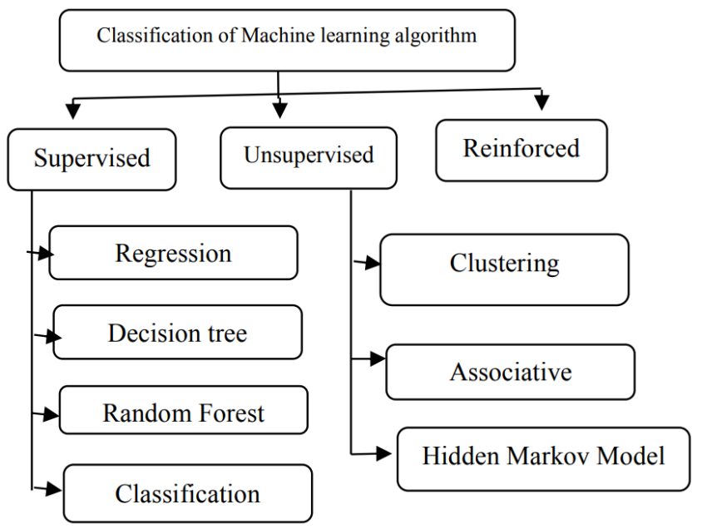

**Fig 3.1. Classification of Machine Learning**

1. **Supervised Learning:**

Supervised learning is defined as learning with a proper guide or learning in the presence of a teacher. We have a training dataset that serves as the teacher for prediction on the given dataset, therefore there is always a training dataset when testing data. The principle of supervised learning is "train me." The following processes are involved in supervised learning:

• Classification

• Random Forest

• Decision tree

• Regression

The phenomena of regression is the recognition of patterns and the measurement of the probability of uninterrupted events.

The system is capable of identifying numbers, their values, and grouping meaning of numbers, such as breadth and height. The supervised machine learning algorithms are as follows:

• Linear Regression

• Logistical Regression

• Support Vector Machines (SVM)

• Neural Networks

• Random Forest

• Gradient Boosted Trees

• Decision Trees

• Naive Bayes

1. **Unsupervised Learning:**

Unsupervised learning is defined as learning without supervision as there is no teacher guiding in unsupervised learning. When using unsupervised learning, a dataset is provided, it will automatically operate on it and find the pattern and interaction between them, and the formed associations, and when fresh data is supplied, it classifies them and save one of them. Unsupervised learning is based on the concept of "self sufficiency".

For example, imagine there are three fruits: mango, banana, and apple, and when Unsupervised learning is used, it classifies them into three different clusters based on their relationship, and when fresh data is provided, it automatically sends it to one of the clusters.

Supervisor learning indicates that there are mango, banana, and apple, whereas unsupervised learning indicates three distinct clusters. The process of unsupervised algorithms is as follows:

• Dimensionality

• Clustering

Following are the unsupervised machine learning algorithms:

• t-SNE

• k-means clustering

• PCA

1. **Reinforcement:**

Reinforced learning is defined as the agent's ability to interact with the environment and determine the outcome. It is based on the "hit and trial" principle. In reinforced learning, each agent is rewarded positive and negative points, and on the basis of positive points, reinforced learning produces dataset output, which is trained on the basis of positive awards, and on the basis of this training, datasets are tested.

* + 1. **Classification Algorithms:**

The classification algorithms are discussed below in detail.

1. **Logistic Regression:**

Logistic regression is a popular Machine Learning method that belongs to the Supervised Learning technique. It is used to predict the categorical dependent variable from a set of independent variables. A categorical dependent variable's output is predicted using logistic regression. As a result, the outcome must be categorical or discrete. It can be Yes or No, 0 or 1, true or False, but instead of presenting the exact values like 0 and 1, it presents the probability values that fall between 0 and 1.

In Logistic regression, instead of constructing a regression line, we fit a "S" shaped logistic function that predicts two maximum values (0 or 1).

The logistic function curve reflects the possibility of something such as whether the cells are cancerous or not, whether a mouse is obese or not based on its weight, and so on.

Logistic Regression is an important algorithm for machine learning because it can generate probabilities and classify new data using both continuous and discrete datasets.

Logistic Regression is one of the most basic machine learning algorithms, and it is simple to implement while providing excellent training efficiency in some cases. Because of these factors, training a model with this algorithm does not necessitate a large amount of computational power. The predicted parameters (trained weights) infer the significance of each feature. It also specifies whether the association is positive or negative. As a result, we can use Logistic Regression to determine the relationship between the features. Unlike Decision Tree or Support Vector Machine, this algorithm allows models to be easily updated to reflect new data. Stochastic gradient descent can be used to update the model. Logistic Regression produces calibrated probabilities as well as classification results. This is superior to models that only provide the final classification as results. We can infer which training examples are more accurate for the formulated problem if one has a 95% probability for a class and another has a 55% probability for the same class.

Logistic Regression is a statistical analysis model that uses independent features to predict precise probabilistic outcomes. On high-dimensional datasets, this may result in the model being over-fit on the training set, which means that the accuracy of predictions on the training set is overstated, and thus the model is unable to predict accurate results on the test set. This is most common when the model is trained on a small amount of training data with a large number of features. To avoid overfitting on high-dimensional datasets, regularisation techniques should be considered (but this makes the model complex). Extremely high regularisation factors may even cause the model to under-fit the training data. Because logistic regression has a linear decision surface, it cannot solve nonlinear problems. In real-world scenarios, linearly separable data is uncommon. As a result, nonlinear features must be transformed, which can be accomplished by increasing the number of features so that the data becomes linearly separable in higher dimensions.

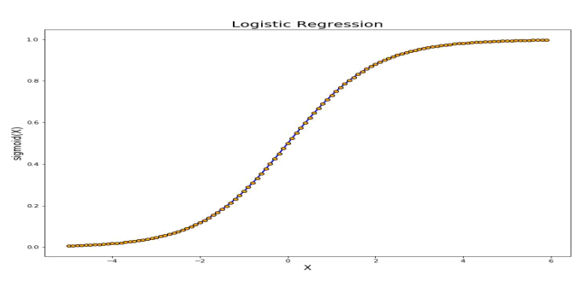

**Fig 3.2. Logistic Regression**

Non-Linearly Separable Data: Using logistic regression to capture complex relationships is difficult. This algorithm is easily outperformed by more powerful and complex algorithms, such as Neural Networks.

1. **Naive Bayes Algorithm:**

The Naive Bayes algorithm is a supervised learning technique that uses the Bayes theorem to solve classification issues. It is mostly utilized in text classification with a large training dataset.

The Naive Bayes Classifier is a basic and effective Classification method that helps in the development of fast machine learning models capable of making quick predictions.

It is a probabilistic classifier, which means it predicts based on an object's likelihood. Spam filtration, sentiment analysis, and article classification are some popular applications of the Nave Bayes Algorithm.

It is a classification method based on Bayes' Theorem and the assumption of predictor independence. A Naive Bayes classifier, in simple terms, assumes that the existence of one feature in a class is unrelated to the presence of any other feature.

The Naive Bayes model is simple to implement and especially useful for very big data sets. In addition to its simplicity, Naive Bayes has been shown to beat even the most advanced classification systems.

The Naive Bayes algorithm is made up of the words "Naive" and "Bayes" which can be described as follows:

● **Naive:** It is called Naive because it assumes that the occurrence of one feature is unrelated to the occurrence of others. For example, if the fruit is identified based on colour, shape, and taste, then a red, spherical, and sweet fruit is identified as an apple. As a result, each feature contributes to identifying it as an apple independently of the others.

**● Bayes:** It is so named because it is based on the principle of Bayes' Theorem.

**Bayes’s theorem:** Bayes' theorem, also known as Bayes' rule or Bayes' law, is a mathematical formula used to calculate the probability of a hypothesis given prior knowledge. It is determined by the conditional probability.

The following is the formula for Bayes' theorem:

**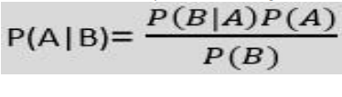**

Where,

P(A|B) is Posterior probability:Probability of hypothesis A on the observed event B.

P(B|A) is Likelihood probability: Probability of the evidence given that the probability of a hypothesis is true.

P(A) is Prior Probability: Probability of hypothesis before observing the evidence.

P(B) is Marginal Probability: Probability of Evidence.

**Types of Naive Bayes model:** The Naive Bayes Model is classified into three types, which are described below:

**• Gaussian:** The Gaussian model assumes that features are distributed normally. This means that

if predictors take continuous values rather than discrete values, the model assumes these values

are drawn from the Gaussian distribution.

**• Multinomial:** When the data is multinomial distributed, the Multinomial Nave Bayes classifier

is used. It is primarily used for document classification problems, indicating which category a

particular document belongs to, such as Sports, Politics, Education, and so on. For predictors, the

classifier employs the frequency of words.

**• Bernoulli:** Similar to the Multinomial classifier, the Bernoulli classifier uses independent

Booleans variables as predictor variables. For example, whether or not a specific word appears in

a document. This model is also well-known for performing document classification tasks.

1. **Decision Tree Algorithm:**

Decision Tree is a Supervised learning technique algorithm that can be used to solve classification and regression problems, however it is most commonly used to solve classification problems. It is a tree-structured classifier in which internal nodes contain dataset attributes, branches represent decision rules, and each leaf node represents the result. A Decision Tree has two nodes: the Decision Node and the Leaf Node.

Decision nodes are used to make decisions and have numerous branches, whereas Leaf nodes represent the results of those decisions and do not have any additional branches. The decisions or tests are based on the characteristics of the given dataset. It is a graphical representation of all possible solutions to a problem/decision given certain parameters. It is termed a Decision Tree because, like a tree, it begins with the root node and then branches out to form a tree-like structure. The CART algorithm, which stands for Classification and Regression Tree algorithm, is used to form a tree. A Decision Tree simply asks a question and split the tree into subtrees based on the answer (Yes/No).

The Decision Tree Algorithm is a member of the supervised machine learning algorithm family. It can be used to solve both a classification and a regression problem.

The goal of this algorithm is to create a model that predicts the value of a target variable, for which the decision tree solves the problem using the tree representation, where the leaf node corresponds to a class label and attributes are represented on the internal node of the tree.

Because there are numerous algorithms in machine learning, the main thing to remember when developing a machine learning model is to select the best algorithm for the given dataset and problem. The Decision Tree is useful for the following reasons:

• Decision trees usually mimic human decision-making abilities, making them simple to understand.

• The logic behind the decision tree is simple to understand because it has a tree-like structure.

The main challenge in Decision Tree is identifying the attribute for the root node in each level. This is referred to as attribute selection.We have two popular measures for attribute selection:

1. **Information Gain:** The entropy changes when we use a Decision Tree node to partition the training instances into smaller subsets. The change in entropy is measured by information gain. Entropy is a measure of a random variable's uncertainty; it characterises the impurity of any arbitrary collection of examples. The higher the entropy, the more information there is.
2. **Gini Index:** The Gini Index is a metric that measures how frequently a randomly selected element is incorrectly identified. This indicates that an attribute with a lower Gini index should be preferred. Sklearn supports "Gini" criteria for Gini Index and takes "gini" value by default.

The following are the most notable Decision Tree algorithms:

1. **IDichotomiser 3 (ID3):** This algorithm employs Information Gain to determine which attribute will be used to categorise the current subset of data. Recursively, information gain is calculated for the remaining data at each level of the tree.
2. **C4.5:** This algorithm is the ID3 algorithm's successor. To determine the classifying attribute, this algorithm employs either Information gain or Gain ratio. Because it can handle both continuous and missing attribute values, it is a direct improvement over the ID3 algorithm.
3. **CART (Classification and Regression Tree):** It is a dynamic learning algorithm that can generate both a regression tree and a classification tree based on the dependent variable.

**Working:**

The algorithm in a Decision Tree predicts the class of a given dataset, begins with the tree's root node. This algorithm compares the root attributes with the record (real dataset) attribute, and as a result branch is followed by a jump to the next node.

The algorithm compares the attribute value with the next node other sub-nodes and progresses. It repeats the procedure until it reaches the leaf. The tree's node

The following algorithm can help better understand the entire process.

Step 1: Begin the tree with the root node, which contains the entire dataset, says S.

Step 2: Using the Attribute Selection Measure, find the best attribute in the dataset (ASM).

Step 3: Subdivide the S into subsets that include potential values for the best attributes.

Step 4: Create the Decision Tree node with the best attribute.

Step 5: Create new decision trees recursively using the subsets of the dataset created in step 3. Continue this process until we can no longer classify the nodes any further and refer to the final node as a leaf node.

1. **Random Forest Algorithm:**

Random Forest is a popular supervised learning algorithm. It is an extension of machine learning classifiers that includes bagging to improve Decision Tree performance. It combines tree predictors, and the trees are reliant on a random vector that is sampled independently. All trees have the same distribution. Instead of splitting nodes based on variables, Random Forests separates nodes by selecting the best predictor subset from the node itself. The worst-case temporal complexity of Random Forests learning is O(M(dnlogn)), where M represents the number of growing trees, n represents the total number of occurrences, and d represents the data dimension.

It can be used for classification as well as regression. It is also the most adaptable and user-friendly algorithm. A forest is made up of trees. It is assumed that the more trees a forest has, the more robust it is. Random Forests generate Decision Trees from randomly picked data samples, obtain predictions from each tree, then vote on the best option. It also serves as a good indicator of the feature importance.

Random Forest is a well-known machine learning algorithm from the supervised learning technique. It can be applied to both classification and regression problems in machine learning. It is based on the concept of ensemble learning, which is a process that involves combining multiple classifiers to solve a complex problem and improve the model's performance.

Random Forest is a classifier that contains a number of decision trees on various subsets of the given dataset and takes the average to improve the predictive accuracy of that dataset," as the name implies. Instead of relying on a single decision tree, the random forest takes the predictions from each tree and predicts the final output based on the majority vote of predictions.

The greater the number of trees in the forest, the higher the accuracy and the lower the risk of overfitting.

**Assumptions:**

Because the random forest combines multiple trees to predict the dataset's class, some decision trees may predict the correct output while others may not. However, when all of the trees are combined, they predict the correct outcome. As a result, the following are two assumptions for a better Random forest classifier:

● There should be some actual values in the dataset's feature variable so that instead of a guessed result, the classifier can predict accurate results.

● Each tree's predictions must have very low correlations.

**Algorithm Steps:**

It works in four steps:

● Select random samples from a given dataset.

● Construct a Decision Tree for each sample and get a prediction result from each Decision Tree.

● Perform a vote for each predicted result.

● Select the prediction result with the most votes as the final prediction.

**Advantages:**

Random Forest can handle both classification and regression tasks. It can handle large datasets with high dimensionality. It improves model accuracy and avoids the overfitting problem.

**Disadvantages:**

Although Random Forest can be used for classification and regression tasks, it is not better suited for regression.

1. **Support Vector Machine (SVM):**

SVM, or Support Vector Machine, is a prominent Supervised Learning technique that is used for both classification and regression problems. However, it is mostly useful in Machine Learning for Classification problems.

The SVM algorithm's purpose is to find the optimum line or decision boundary for categorising n-dimensional space so so that we can easily place new data points in the correct category in the future. A hyperplane is the best choice boundary. SVM selects the extreme points/vectors that help in the creation of the hyperplane. These extreme situations are known as support vectors, and the algorithm is known as the Support Vector Machine.

Support vector machines (SVMs) are supervised machine learning algorithms that are both powerful and flexible. They are used for classification and regression. However, they are most commonly used in classification problems. SVMs were first introduced in the 1960s, but they were refined in 1990. When compared to other machine learning algorithms, SVMs have a distinct implementation method. They have recently become extremely popular due to their ability to handle multiple continuous and categorical variables.

The following are key concepts in SVM:

Support Vectors - Support vectors are data points that are closest to the hyperplane. These data points will be used to define a separating line.

Hyperplane - A hyperplane is a decision plane or space that is divided between a set of objects of different classes.

Margin - The distance between two lines on the closest data points of different classes. It is the perpendicular distance between the line and the support vectors. A large margin is regarded as a good margin, while a small margin is regarded as a bad margin.

**Types of SVM:**

SVM are of two types:

1. Linear SVM - Linear SVM is used for linearly separable data, which means that if a dataset can be classified into two classes using a single straight line, it is considered linearly separable data, and the classifier used is the Linear SVM classifier.
2. Non-linear SVM - Non-linear SVM is used for non-linearly separated data, which means that if a dataset cannot be classified using a straight line, it is considered non-linear data, and the classifier used is the Non-linear SVM classifier.

The support vector machine algorithm seeks a hyperplane in a Ndimensional space (N - the number of features) that distinguishes between data points.

The advantages of support vector machines are:

● Effective in high dimensional spaces.

● Still effective in cases where the number of dimensions is greater than the number of samples.

● Uses a subset of training points in the decision function (called support vectors), so it is also memory efficient.

● Versatile: different kernel functions can be specified for the decision function. Common kernels are provided, but it is also possible to specify custom kernels.

The disadvantages of support vector machines include:

● If the number of features is significantly greater than the number of samples, avoid over-fitting when selecting Kernel functions, and the regularisation term is critical. SVMs do not directly provide probability estimates; instead, they use an expensive five-fold cross-validation procedure.

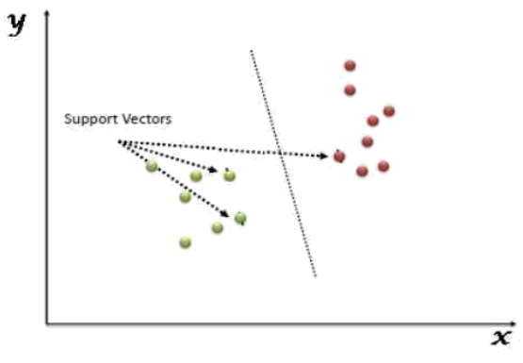

**Fig 3.3. Support Vector Machine**

1. **K Nearest Neighbor (KNN):**

K Nearest Neighbor (KNN) is a machine learning technique which is simple, simple to understand and versatile. KNN is useful in many areas, including banking, healthcare, political science, handwriting recognition, image identification, and video recognition. Financial institutions will predict consumers' credit ratings in credit ratings. Banking institutions will predict if a loan is safe or dangerous during loan disbursement. In political science, potential voters are divided into two groups: those who will vote and those who will not vote. The KNN technique is applied to classification and regression problems. The KNN algorithm is based on the feature similarity method.

The algorithm’s learning is:

1. Instance-based learning: Unlike model-based algorithms, we use entire training instances to predict output for unseen data rather than learning weights from training data.

2. Lazy Learning: The model is not learned using prior training data, and the learning process is postponed until prediction on the new instance is requested.

3. Non-Parametric: There is no predefined mapping function form in KNN.

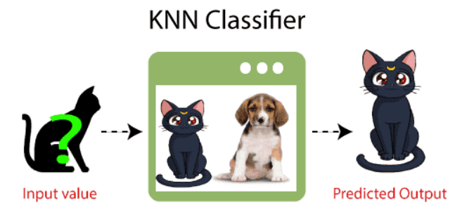

**Fig 3.4. KNN Classifier**

1. **XG-boost Algorithm:**

XG-boost is an implementation of Gradient Boosted decision trees. It is a type of software library that was created to improve model speed and performance. This technique generates decision trees in a sequential fashion. Weights are very significant in XG-boost. All of the independent variables are given weights, which are subsequently fed into the decision tree, which predicts results. The weight of variables incorrectly predicted by the tree is increased, and these variables are subsequently fed into the second decision tree. These various classifiers/predictors are then combined to form a more powerful and precise model. It is capable of doing regression, classification, ranking, and user-defined prediction.

Regularization: XG-boost includes L1 (Lasso Regression) and L2 (Ridge Regression) regularisation to prevent overfitting. As a result, XG-boost is also known as the regularised form of GBM (Gradient Boosting Machine). Using the Scikit Learn library, we pass two regularisation hyper-parameters (alpha and lambda) to XG-boost. L1 regularisation is done with alpha, and L2 regularisation is done with lambda.

Parallel Processing: Because XG-boost makes use of parallel processing, it is much faster than GBM. The model is run on multiple CPU cores. The nthread hyper-parameter is used for parallel processing when using the Scikit Learn library. The number of CPU cores to be used is represented by nthread. If we want to use all available cores, leave nthread blank and the algorithm will detect it for us.

Missing Values: XG-boost includes the ability to handle missing values. When XG-boost encounters a missing value at a node, it attempts both the left and right hand split and learns the path that results in a higher loss for each node. It then repeats the process when working with the testing data.

Cross Validation: XG-boost allows the user to perform cross-validation at each iteration of the boosting process, making it simple to obtain the exact optimum number of boosting iterations in a single run. In contrast to GBM, we must run a grid-search and only a limited number of values can be tested.

Effective Tree Pruning: When a GBM encounters a node, it will stop splitting it and he split resulted in a loss. As a result, it is more of a greedy algorithm. XG-boost, on the other hand splits the tree up to the max depth specified, then begin pruning it.backwards and eliminate splits where there is no positive gain.

* 1. **Design Constraints:**

While creating and designing our project, our main focus will on considering user’s software requirement and browser support. Hence our project’s main constraints and requirements will be on the following:-

* + 1. **Hardware Requirement:**
* i3 6th generation Processor Based Computer or higher
* Memory: 512 GB
* Hard Drive: 500 MB
* SSD: 500 MB
* Internet Connection
  + 1. **Software Requirement:**
* Operating System - Windows 7 (or higher), Mac OS, Linux etc.
* Web Browser
  + 1. **Technologies:**
* Jupyter Notebook
* Python 3.10
  1. **Analysis and Feature finalization subject to constraints**

Of the 76 attributes available in the dataset, 13 attributes are considered for the prediction of the output. The predictor for the diagnosis of Heart Disease in our project is determined by these 13 features. All attributes are listed in ‘Table 1’.

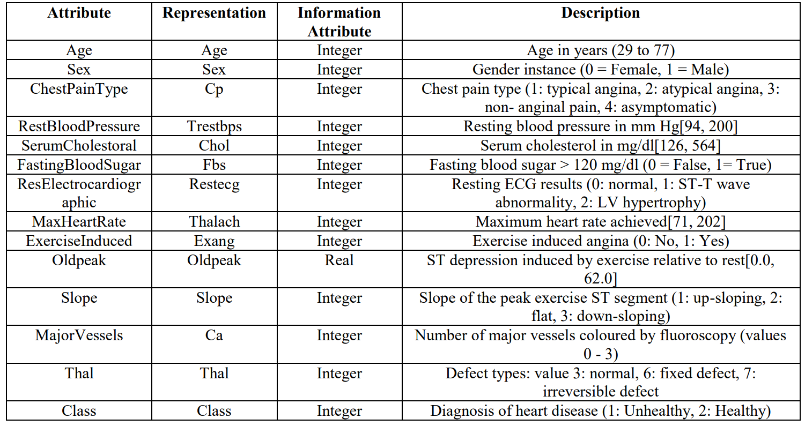

**Table 3.1. Attributes of the Heart disease dataset**

* 1. **Design Flow:**

The data flow diagrams (Fig. 3.5 & Fig 3.6) are a visual representation of how data moves through our system.

The major components of System Architecture 1 are as follows: -

Patient Database, Data Processing, Exploratory Data Analysis, Classification Algorithms, Feature Selection and Results.

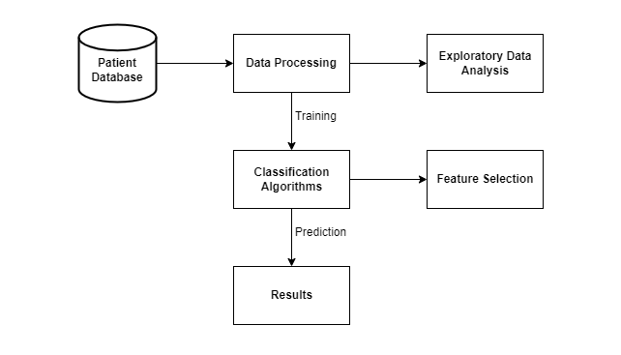

**Fig 3.5. System Architecture 1**

**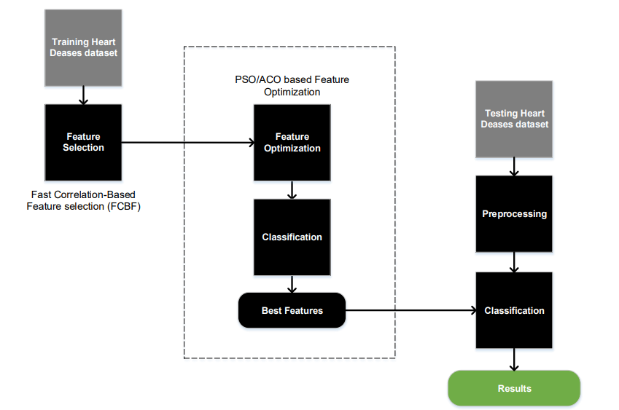**

**Fig. 3.6. System Architecture 2**

An alternate structure of the proposed system is shown in Fig. 3.5. This system consists of feature selection based Fast Correlation-Based Feature selection (FCBF), feature selection based PSO (Particle Swarm Optimization) combined with ACO (Ant Colony Optimization), and classification components based on K-Nearest Neighbour, Support Vector Machine, Naïve Bayes, Random Forest and Artificial Neural Network. The training dataset is prepared according to a binary class classification problem. From the training dataset, features are selected, after that the best subset of features is optimized by our combined PSO/ACO algorithm and then, by using the selected best features, new features are classified with WEKA.

However, implementing our model using the System Architecture 2 produces slow and less accurate predictions. So, we decided to go with System Architecture 1

* 1. **Design Selection:**

For our project we will be using the second approach i.e., System Architecture 1

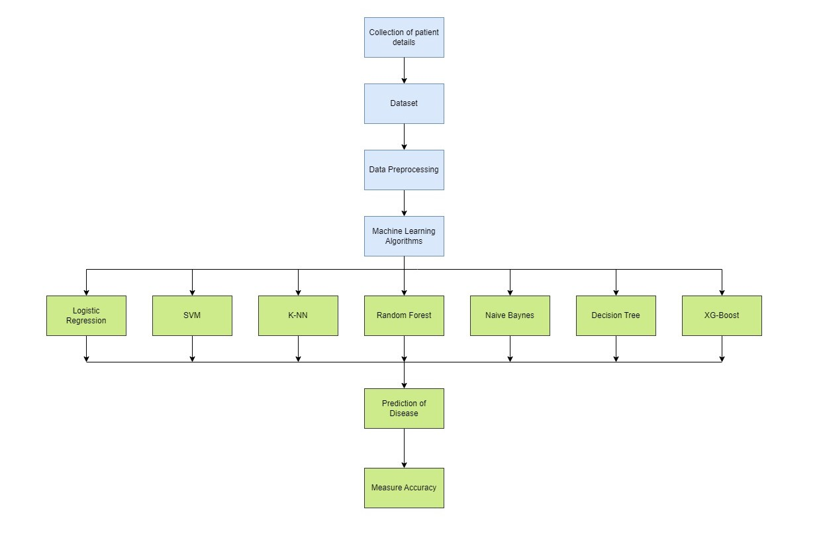

**Fig 3.7. Design Flow of the System**

The flow chart of the system is described below:

Dataset collection is the process of gathering information on patients.

The process of selecting useful attributes for the prediction of heart disease is known as attribute selection. Following the identification of available data resources, they are further processed, cleansed, and transformed into the suitable form. Different classification techniques (as mentioned above) will be used on preprocessed data to predict the accuracy of heart disease. The accuracy metric compares the accuracy of various classifiers.

Our heart disease prediction system is comparable to Fig. 3.++, which also describes the research methods for creating a classification model needed for the prediction of heart problems in patients. The model serves as the foundation for predicting heart disease using any machine learning technique. To make predictions, a classifier must be trained using the dataset, and then a classification model must be created, which is then fed a new unknown record, and the forecast is formed.

* 1. **Implementation Plan:**

This project is implement using the following modules:

1. Data Wrangling
2. Exploratory Data Analysis
3. Model Training Using Machine Learning Algorithms
4. Finding Feature Importance.

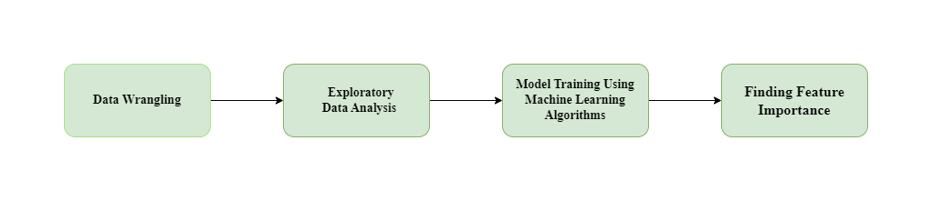

**Fig 3.8. Block Diagram of the System**

* + 1. **Data Wrangling:**

First we will import the required libraries and dataset then we'll start by converting the dataset we're working with into a simpler and more readable format.

**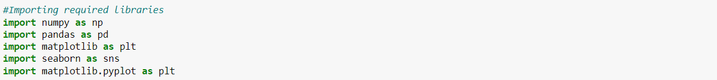**

The above code helped us display our data in tabular form.

**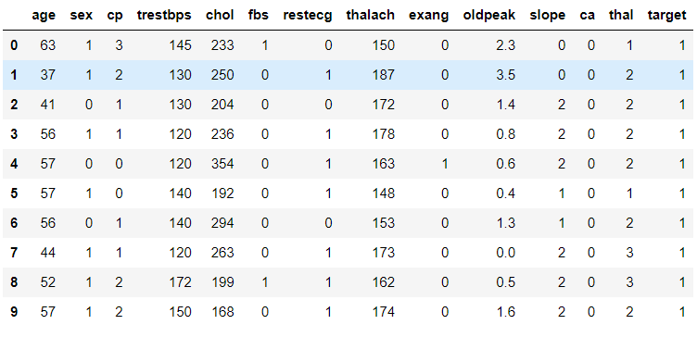**

**Table 3.2. Dataset**

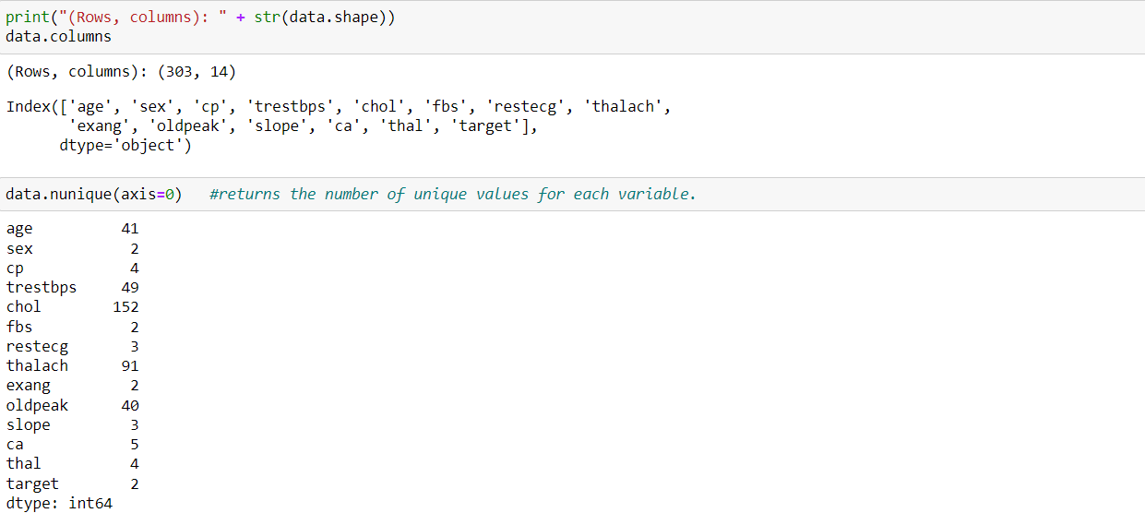

The following code will give us the total number of rows and columns and the column names in our dataset. The total number of rows and columns in our data is 303 and 14 respectively. Then we will use the data.nunique() function to get the number of unique values for every variable.

In the next step, we will use data.describe() to summarize the count, mean, standard deviation, min, and max for numeric variables.



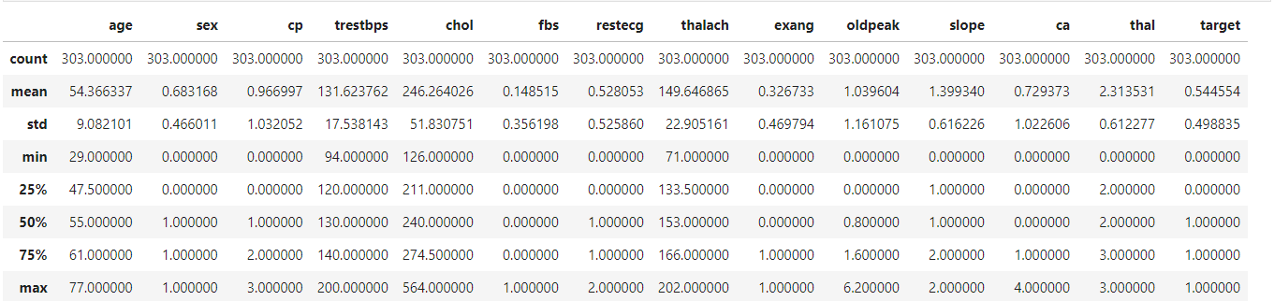

**Table 3.3. Summary of the Dataset**

* + 1. **Exploratory Data Analysis:**

After completing data wrangling, we are going to perform exploratory data analysis. We will perform some primary tasks at this stage.

**Finding Correlations:**

We will built a correlation matrix to see whether something is positively or negative correlated with our predictor.

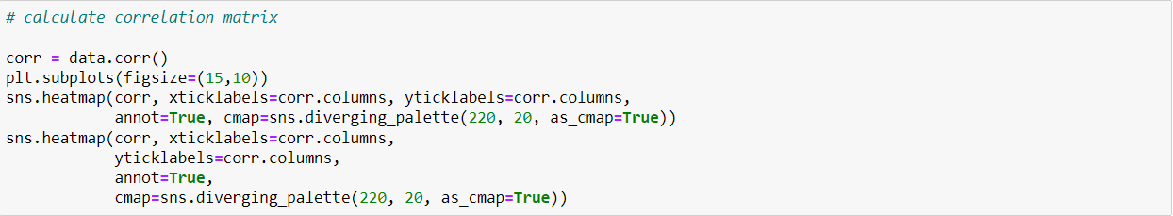

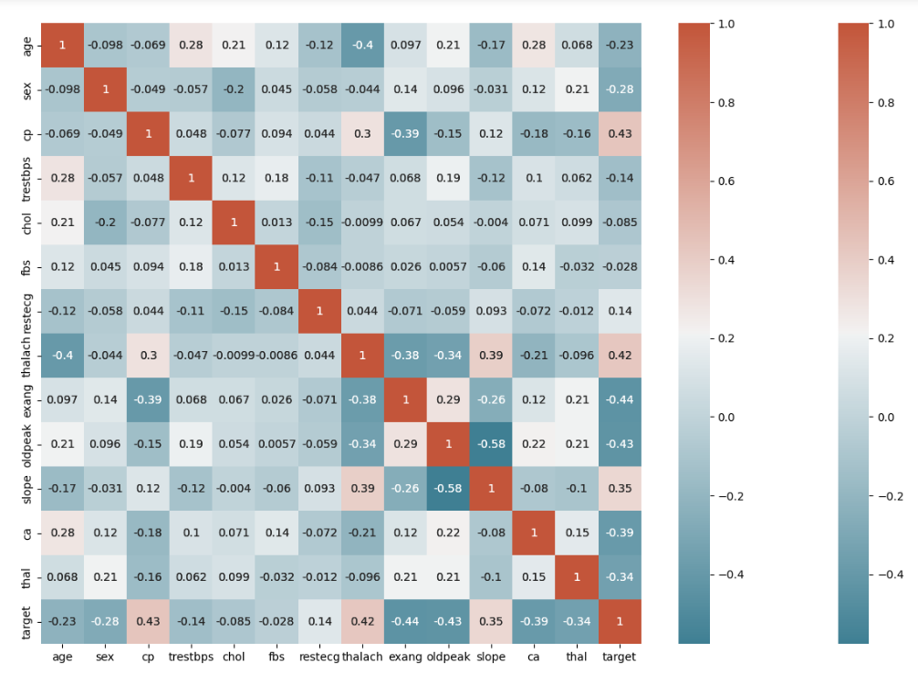

**Fig 3.9. Correlation Matrix**

We can observe that there is a positive correlation between chest pain (cp) and the target (our predictor). This makes sense because having more chest pain increases the chances of developing heart disease. Cp (chest pain) is a four-valued ordinal feature with 4 values:

Value 1: typical angina ,Value 2: atypical angina, Value 3: non-anginal pain , Value 4: asymptomatic.

Furthermore, there is a negative correlation between exercise-induced angina (exang) and our predictor. This makes sense because the heart wants more blood when you exercise, but narrower arteries restrict blood flow.

Pairplots are also an excellent way to see the correlations between all variables. But we'll construct it with only continuous columns from our data because seeing each one can be challenging with so many features. Instead, we'll create a pairplot using solely our continuous features.



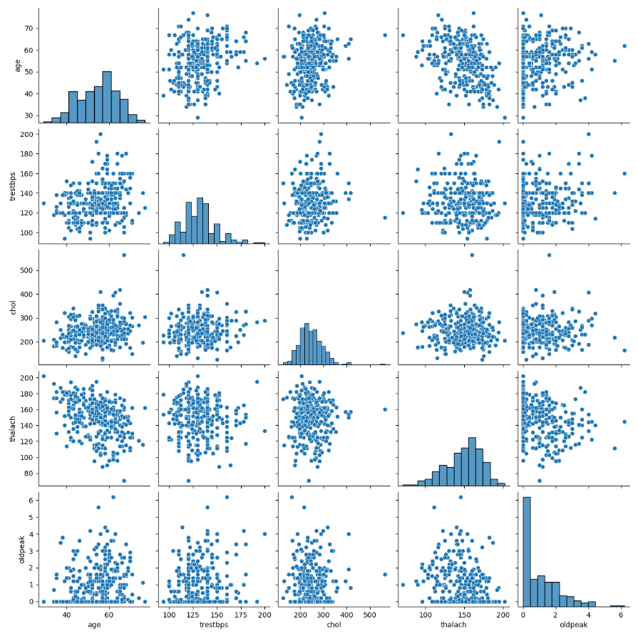

**Fig 3.10. Pairplots**

To look more deeply into the correlations, We created a smaller pairplot with only the continuous variables. Also useful for determining whether there is a positive or negative correlation.



When the ventricle is at rest and hence repolarized, ST segment depression occurs. This heart disease can occur if the trace in the ST segment is pretty low below the baseline. This supports the plot above because those with low ST Depression are more likely to develop heart disease. While a high ST depression is natural and healthy. The slope hue relates to the peak workout ST segment, with values ranging from 0 to 2 (upsloping, flat, and downsloping). Patients with positive and negative heart disease had equal distributions of the three slope groups.

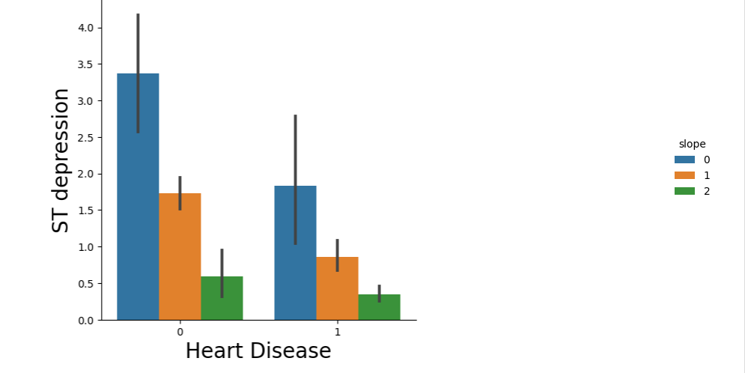

**Fig 3.11. ST depression (induced by exercise relative to rest) vs. Heart Disease**

**Using Violin and Box Plots:**

The Violin and Box plots can be used for displaying the basic statistics of the data as well as its distribution. These plots are frequently used to compare the distribution of a variable across different categories. It displays the median, interquartile range, and Tukey's fence (minimum, first quartile (Q1), median, third quartile (Q3), and maximum). Furthermore, it can identify outliers in our data.



The overall shape and distribution of negative and positive patients differ dramatically. Positive patients have a lower median for ST depression level and consequently a wide dispersion of their data between 0 and 2, whereas negative patients have a distribution between 1 and 3. Furthermore, there aren't many differences between male and female target outcomes.

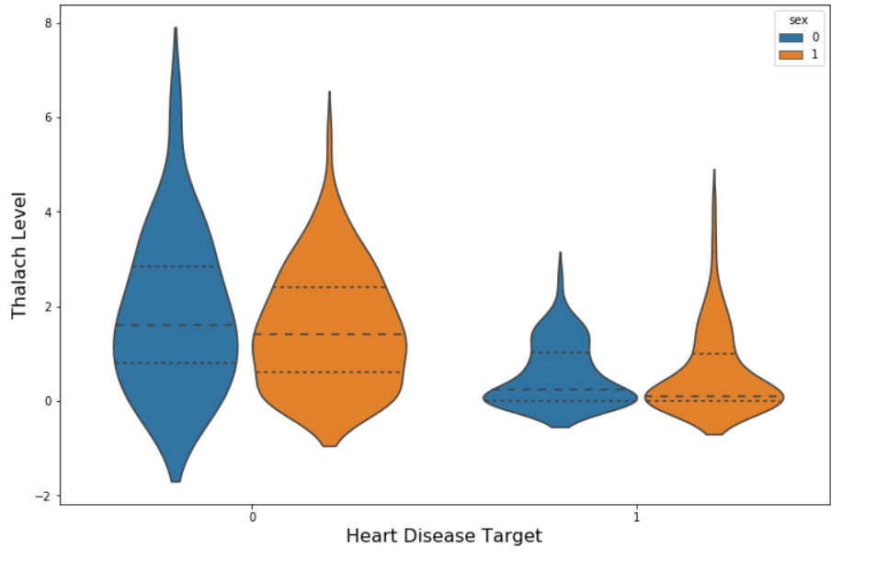

**Fig 3.12. Thalach Level vs. Heart Disease**

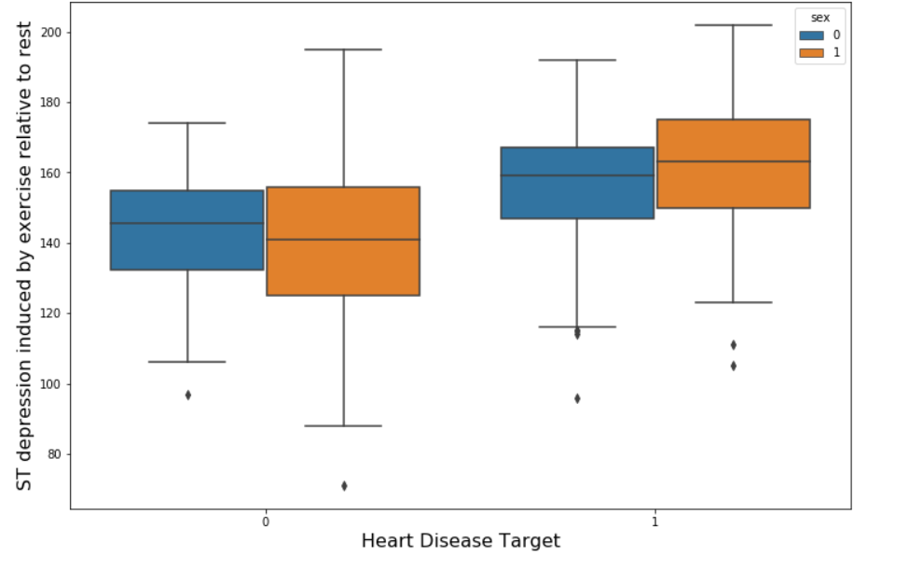

**Fig 3.13. ST depression Level vs. Heart Disease**

Positive patients had a higher median level of ST depression, whereas negative patients have lower levels. Furthermore, we don't noticesee any significant differences between male and female target outcomes, except for males having slightly greater ranges of ST Depression.

**Filtering data by positive & negative Heart Disease patient:**

**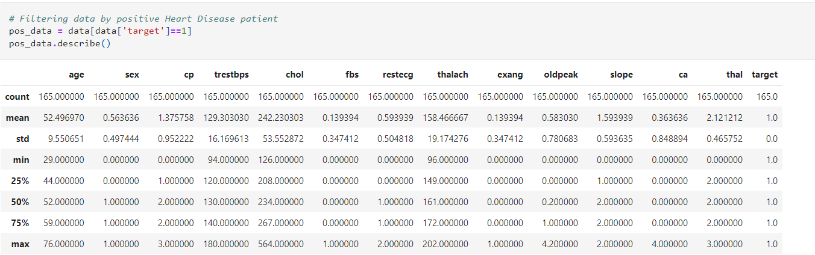**

**Table 3.4. Positive Heart Disease Patients**

**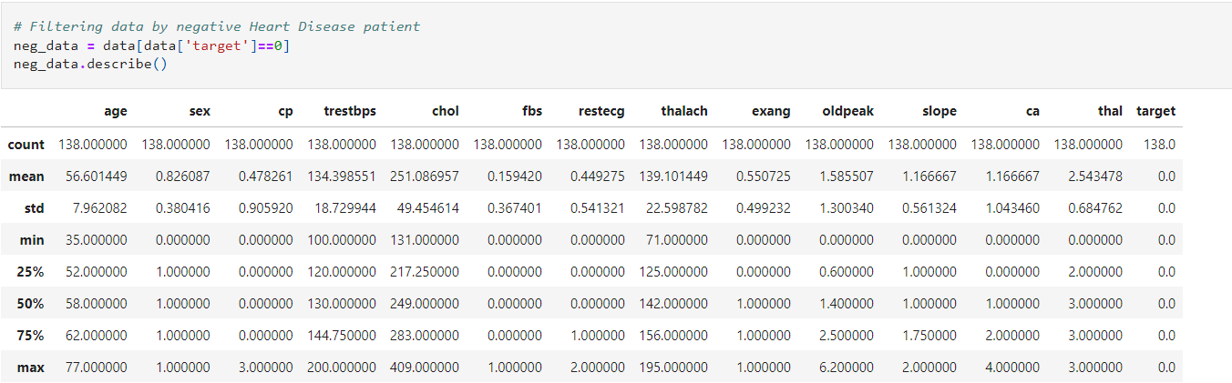**

**Table 3.5. Negative Heart Disease Patients**

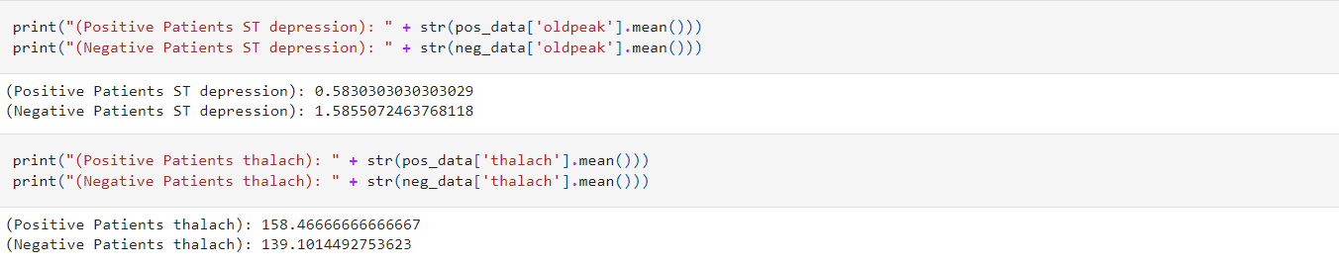

When we compare positive and negative patients, we can observe that there are significant differences in means for several of our features. Examining the facts reveals that positive patients have a higher average maximal heart rate reached (thalach). Furthermore, positive individuals have roughly one-third the amount of ST depression caused by activity compared to rest (oldpeak).

* + 1. **Model Training Using Machine Learning Algorithms:**

**Preparing the Data for Modeling:**

First, assign the 13 features to X and the last column to the predictor Y. Then, we’ll split the data into two sets I.e., training set and test set. Finally, we'll normalise the data so that its distribution has a mean of zero and a standard deviation of 1.

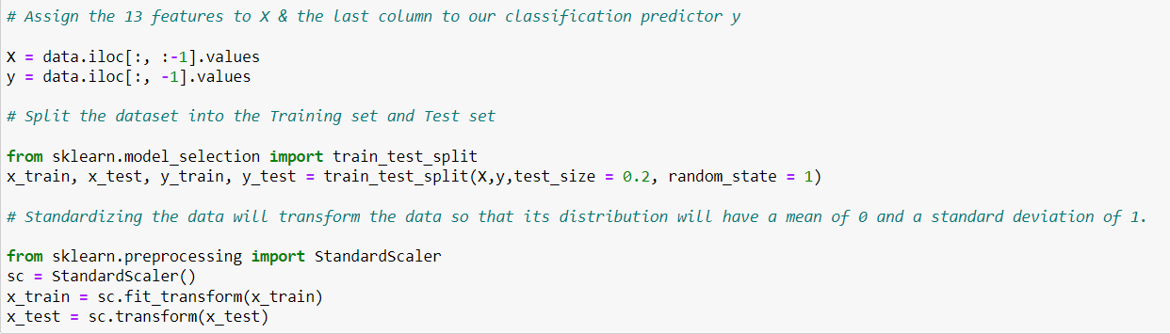

**Training:**

Now, we will train various Classification Models on the training set to discover which one produces the highest accuracy. Then, the accuracy of Logistic Regression, K-NN, SVM, Naives Bayes Classifier, Decision Trees, Random Forest, and XGBoost will be compared.

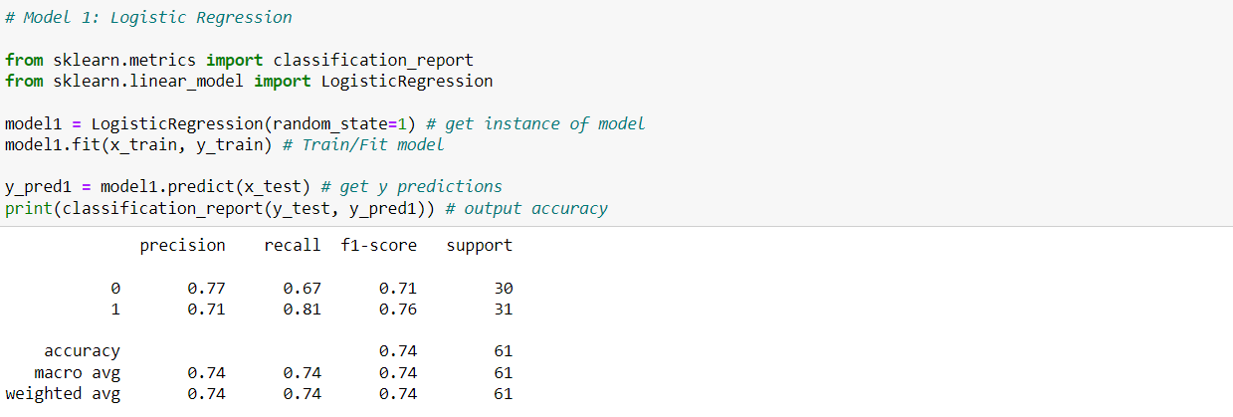

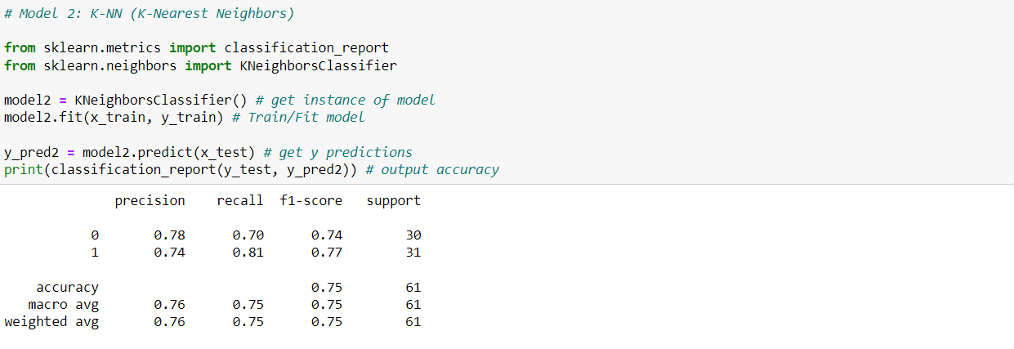

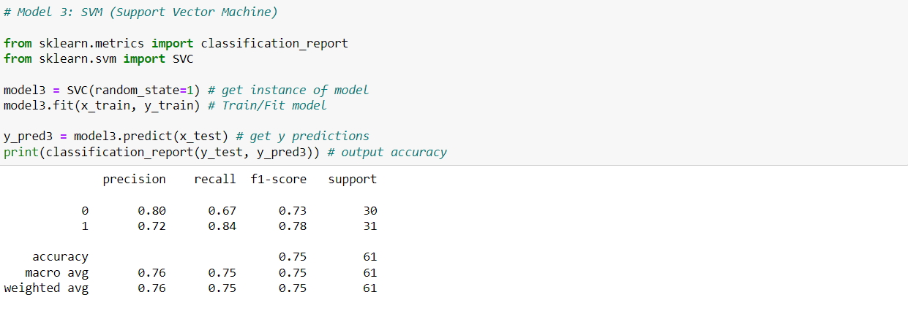

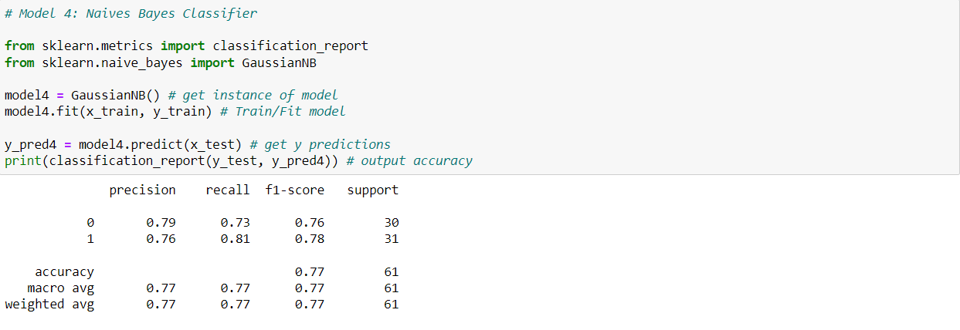

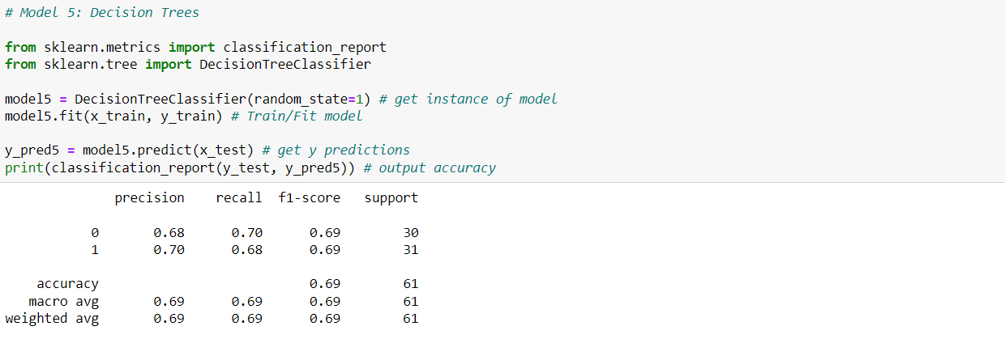

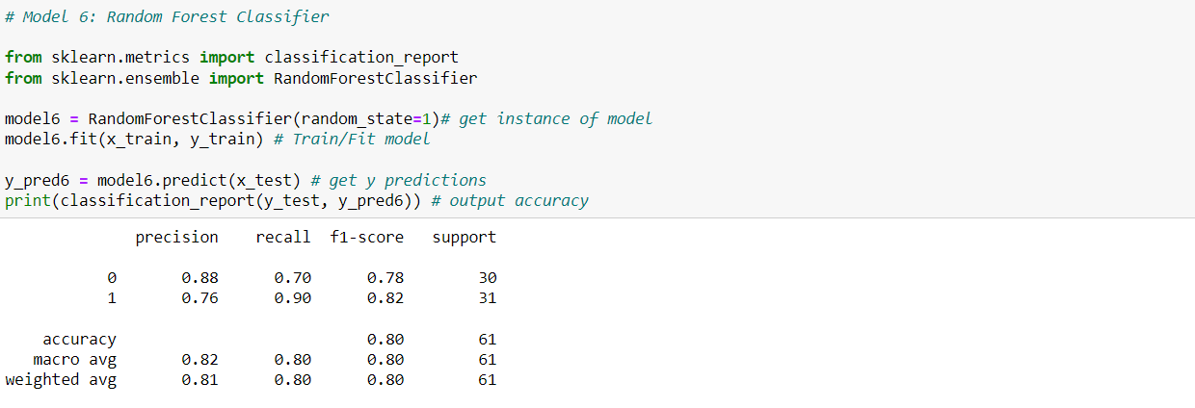

**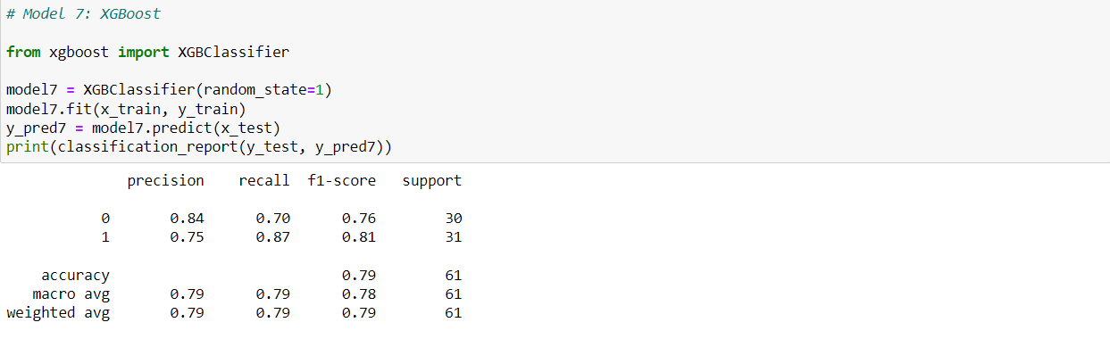**

We can conclude from comparing the seven models that Model 6: Random Forest has the highest accuracy with an 80% accuracy.

We also have precision, recall, F1-score and support for performance analysis:

Precision may be defined as "how many patient in that class are accurately classified."

Recall may be defined as "how many of this class you find out of the total number of elements in this class"

The F1-score is the harmonic mean of the precision and recall scores.

The F1 score reaches its highest value at 1 and its lowest value at 0.

F1 Score = 2 \* (precision x recall) / (precision + recall)

Support is the number of true response samples in that class.

**Making the Confusion Matrix:**

**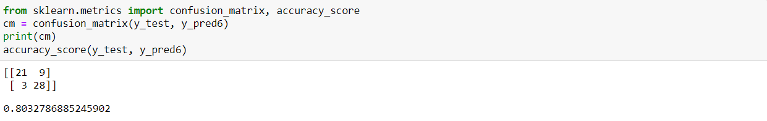**

The number of True Positives in our data is 21, whereas the number of True Negatives is 28.

The amount of errors is 9 & 3.

* + 1. **Finding Feature Importance**:

Feature Importance calculates a score indicating on how useful each feature was in our model. The higher the Feature Score, the more frequently that feature is used to make vital decisions, making it more essential.

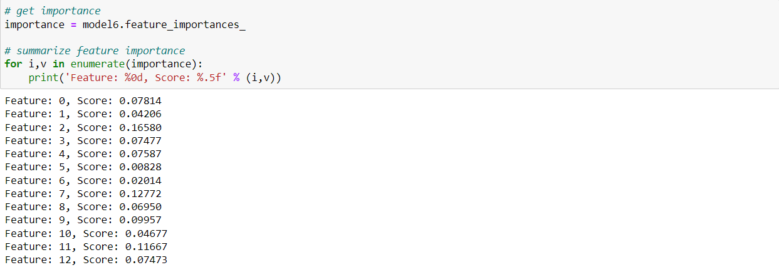

The top four significant features, according to the Feature Importance graph (Fig), were chest pain type (cp), maximal heart rate achieved (thalach), number of main vessels (ca), and ST depression generated by exercise relative to rest (oldpeak).

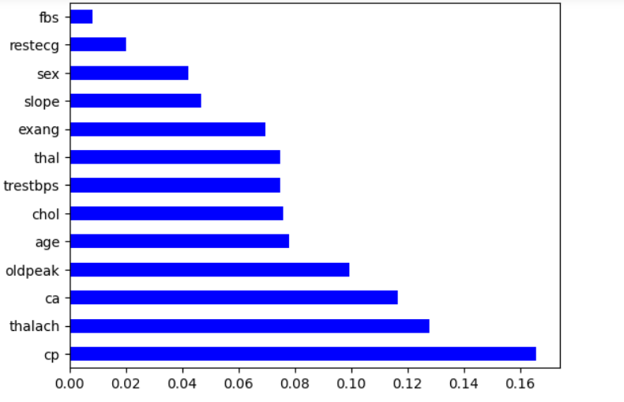

**Fig 3.14. Feature Importance Graph**

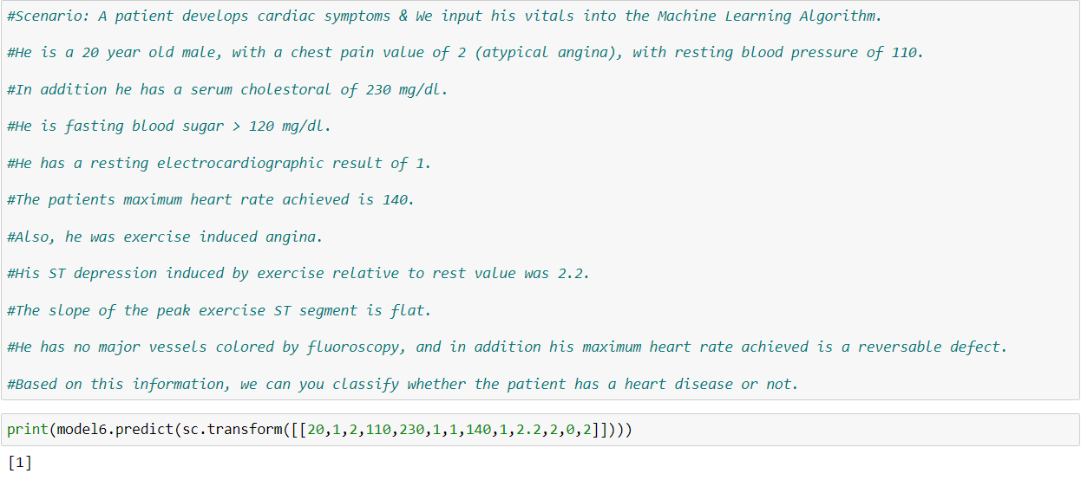

Our machine learning algorithm has detected that this patient has a Heart Disease. Now we can correctly diagnose him and get him the treatment he requires to recover. We may be able to prevent worse symptoms from appearing later.

**Predicting the dataset results:**

The first value is our predicted value, while the second value is our actual value. If the values match, we accurately predicted. Our results are quite accurate, as we can see below.



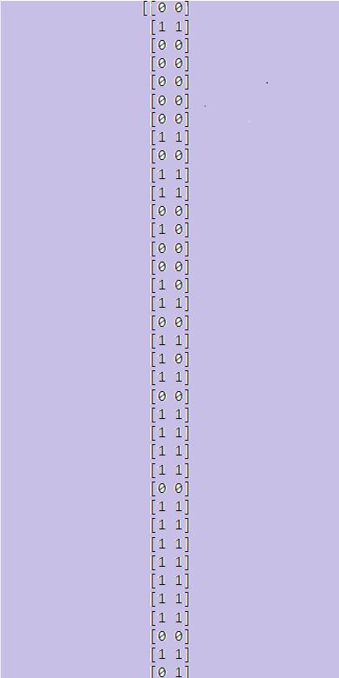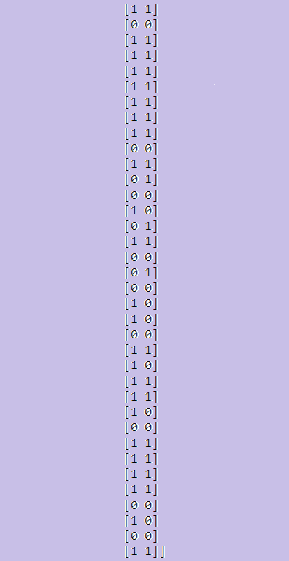

**CHAPTER 4**

**RESULTS ANALYSIS AND VALIDATION**

* 1. **Implementation of solution:**
     1. **Analysis:**

For evaluating the experiment, various evaluation metrics like accuracy, confusion matrix, precision, recall, and f1-score are considered.

**Confusion Matrix:**

A confusion matrix, also called as an error matrix, is a table that is used to describe the performance of a classification model (or "classifier") on a collection of test data with known true values. It enables the visualization of an algorithm's performance. It enables easy identification of class confusion, such as when one class is frequently mislabeled as the other. The key to the confusion matrix is that the number of correct and incorrect predictions, as well as the number of errors made, are summed with count values and broken down by class.

|  |  |
| --- | --- |
| TP=21 | FP=9 |
| FN=3 | TN=28 |

**Table 4.1. Confusion Matrix**

Here,

• TP represents True Positive = Observation is positive and is predicted to be positive.

• FN represents False Negative = Observation is positive but is predicted negative.

• TN represents True Negative = Observation is negative and is predicted to be negative.

• FP represents False Positive = Observation is negative but is predicted positive.

**Accuracy:**

Accuracy is defined as the ratio of correct predictions to total inputs in the dataset.

It is given as follows:

Accuracy = (TP + TN)/(TP+FP+FN+TN) = (21+28)/(21+28+9+3) = 0.80 = 80% accuracy

Any accuracy beyond 70% is regarded good but if the accuracy is too high, it may be too good to be true (an example of Overfitting). As a result, 80% accuracy is optimal.

Accuracy is defined as the ratio of correct predictions to total inputs in the dataset.

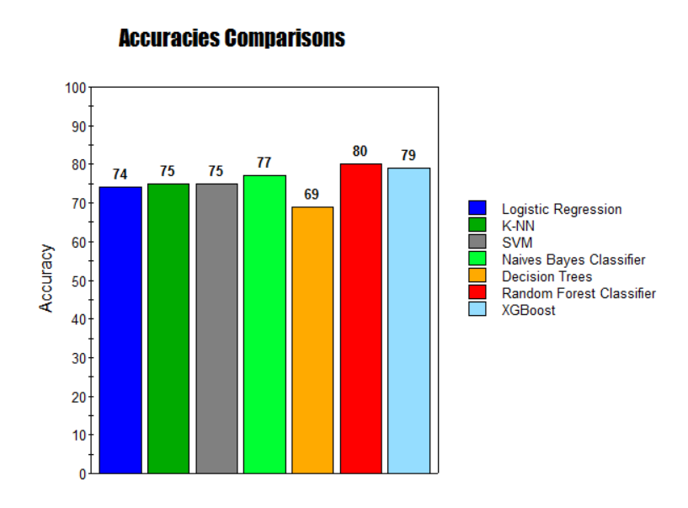

**Fig 4.1. Accuracy Scores**

**Recall:**

The ratio of the total number of correctly categorized positive examples divided by the total number of positive examples is known as recall. High recall suggests that the class was accurately identified (a small number of FN). Recall is calculated as follows:

Recall = TP/(TP+FN) = 21/(21+3) = 0.875

**Precision:**

Precision is calculated by dividing the total number of correctly classified positive examples by the total number of predicted positive examples. High Precision means that an example labelled as positive is, in fact, positive (a small number of FP). Precision is expressed as:

Precision = TP/(TP+FP) = 21/(21+9) = 0.7

**F1-Score:**

F1-score is the harmonic mean of Precision and recall. It measures the accuracy of the test. This measure has a scale of 0 to 1.

F1 Score = 2 x ((precision \* recall) / (precision + recall)) = 2(0.7\*0.875)/(0.7+0.875) = 0.78

* + 1. **Results:**

We implemented this project in Python programming language using Jupyter Notebook IDE. This project focuses on heart disease diagnosis by considering previous data and information. To achieve this we started our implementation of the project by performing some basis analysis on the dataset. The required data is assembled in a standardized form. For predicting the chances of heart disease in a patient, the following attributes are being fetched from the medical profiles, these include: age, BP, cholesterol, sex, blood sugar etc.

After analyzing the data, we implemented various classification algorithms on the training dataset. Classification algorithms basically identify the category of new observations on the basis of training data. In Classification, a program learns from the given dataset or observations and then classifies new observation into a number of classes or groups such as, Yes or No, 0 or 1. Of all the classification algorithms, Random Forest Classifier gave the highest accuracy followed by XGBoost. Random Forest models are a kind of non parametric models that can be used both for regression and classification. They are one of the most popular ensemble methods, belonging to the specific category of Bagging methods.

Ensemble methods involve using many learners to enhance the performance of any single one of them individually. These methods can be described as techniques that use a group of weak learners (those who on average achieve only slightly better results than a random model) together, in order to create a stronger, aggregated one.

In our case, Random Forests are an ensemble of many individual Decision Trees, the family of Machine Learning models we saw just before.

Random Forest introduce randomness and numbers into the equation, fixing many of the problems of individual decision trees, like overfitting and poor prediction power.

In a Random Forest each tree is built using a subset of the training data, and usually only a subset of the possible features. As more and more trees are built, a wider range of our data is used, and more features come into play, making very strong, aggregated models.

Individual trees are built independently, using the same procedure as for a normal decision tree but with only a random portion of the data and only considering a random subset of the features at each node. Aside from this, the training procedure is exactly the same as for an individual Decision Tree, repeated N times.

To make a prediction using a Random Forest each an individual prediction is obtained from each tree. Then, if it is a classification problem, we take the most frequent prediction as the result, and if it is a regression problem we take the average prediction from all the individual trees as the output value.

* + 1. **Testing:**

Testing is important for any web or software projects that’s because it helps in getting bugs out and catching details that we might have missed initially. Software testing is a technique for verifying if the actual software products meet the desired specifications and guarantees that it is error-free. It comprises putting software/system parts through their paces with the aid of manual or automated techniques in order to assess one or more interesting properties. We will make sure that our system works the way we want it to in all cases.

We created a dummy project before creating the original in order to test our algorithms.

We basically implemented all classification algorithms individually on the dataset. Following were the reason for creating dummy project :-

1) Testing the implementation of each classification algorithms.

2) Testing the performance of each classification algorithms.

3) Checking if the data is getting processed correctly.

4) Checking if the selected attributes are producing correct results.

**Unit Testing :-** Individual software modules or components are tested as part of a type of software evaluation known as unit testing. The goal is to confirm that each piece of software code operates as intended. Developers perform unit testing while creating an application (the coding phase). Unit tests isolates a specific piece of code and validate its accuracy. An singular function, method, module, procedure, or objects might be considered a unit. In our dummy project we tested all algorithmic components inside the grid of various sizes. We checked if all the classification algorithms functions are correctly or not by making them run of different datasets. We made every components of the project robust.

**Integeration Testing :-** Software components are logically connected and tested as a unit in a type of testing called integration testing. Multiple software modules created by various programmers make up a typical software project. This level of testing's objective is to find issues with how various software modules interact when they are combined. Implementing different classification algorithms is the most important part of our project. After testing, we found that all the algorithms are working correctly.

**Acceptance Testing :-** Acceptance tests are official testing that determine whether a system complies with the specifications. They concentrate on reproducing user actions while executing the complete application during testing. However, if certain objectives are not achieved, they can go even further and assess the system's performance and make changes as necessary. The system acceptance level is tested with the required number of users in a manner similar to black box testing. The fourth and final phase of software testing is this one.For ensuring our project works correctly and as per our requirements, we tested our project on different datasets. We found that our project is working on every dataset correctly and smoothly. However, the accuracy of the different classification algorithms vary in some cases. We also tested the selected attributes to understand their impact on the prediction

Since different attributes have different resulting predictions , following images shows the distribution the dataset.

The distribution of age, sex, chest pain, trestbps, the distribution of cholesterol, fasting blood, ecg resting electrode and thalach etc are analyzed and the conclusion is drawn as shown in Figures below.

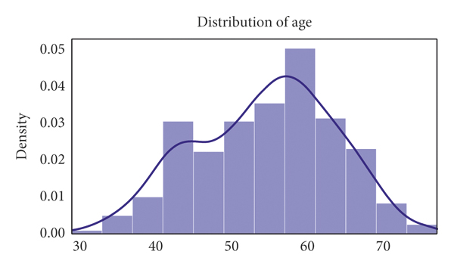

**Fig 4.2. Distribution of age**

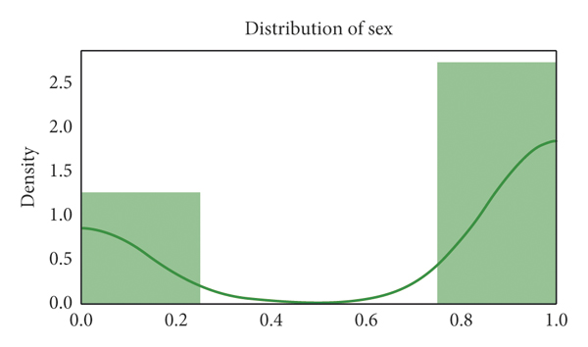

**Fig 4.3. Distribution of sex**

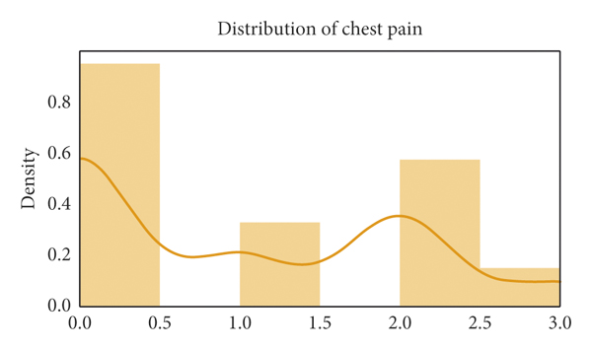

**Fig 4.4. Distribution of chest pain**

By analyzing the distribution plots, it is visible that thal and fasting blood sugar is not uniformly distributed and they needed to be handled; otherwise, it will result in overfitting or underfitting of the data.

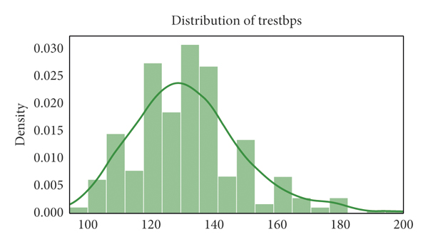

**Fig 4.5. Distribution of chest trestbps**

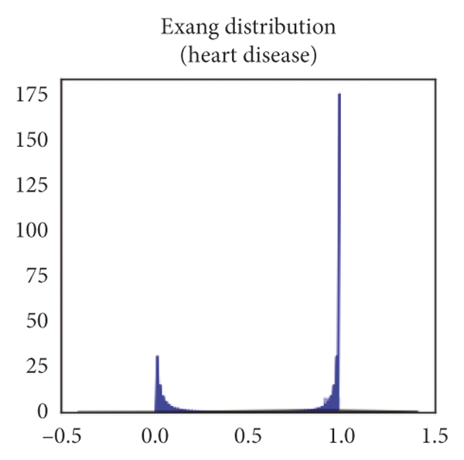

**Fig 4.6. Distribution of Exang**

**CHAPTER 5**

**CONCLUSION AND FUTURE WORK**

**5.1. Conclusion:**

Heart disease is a major killer in India and around the world; applying promising technology such as machine learning to the early prediction of heart disease would have a significant influence on society. Early detection of heart disease can help high-risk patients make lifestyle changes and, as a result, prevent complications, which can be an important achievement in the area of medicine. Every year, more people are diagnosed with heart disease. This requires an early diagnosis and therapy. The use of appropriate technology support in this area can be extremely valuable to the medical community and patients. Logistic Regression, Nave Bayes, SVM, Decision Tree, K-NN, Random Forest and XGBoost are the seven machine learning algorithms used to in this project.

The projected attributes leading to heart disease in patients are present in the dataset, which contains 76 features, 13 of which are crucial for evaluating the system. If all of the features are taken into account, our system will have a lower efficiency. Attribute selection is done to improve efficiency. In this case, n features must be chosen in order to evaluate the model with greater accuracy. Because the correlation of several features in the dataset is almost equal, they are discarded. When all of the attributes in the dataset are included, the efficiency drops dramatically.

The accuracies of all seven machine learning methods are compared, and one prediction model is developed as a result. Hence, the goal is to use multiple evaluation measures such as confusion matrix, accuracy, precision, recall, and f1-score to efficiently predict the disease. When all seven are compared, the extreme Random Forest algorithm has the greatest accuracy of 80%.

**5.2. Future Work:**

The future work in this area can be made to produce an impact on the accuracy of the various classification algorithms. For additional improvement applying genetic algorithm in order to reduce the actual data for acquiring the optimal subset of attribute that is perfectly adequate for heart disease prediction. The automated prediction of heart disease using actual real-time data from health care organizations that can be produced using big data. They can be fed as streaming data, and using the data, a real-time study of the patients can be prepared.

**REFERENCES**

1. World Health Organization, *Cardiovascular Diseases*, WHO, Geneva, Switzerland, 2020, [https://www.who.int/health-topics/cardiovascular-diseases/#tab=tab\_1](https://www.who.int/health-topics/cardiovascular-diseases/" \l "tab=tab_1" \t "https://www.hindawi.com/journals/cin/2021/8387680/_blank).
2. American Heart Association, *Classes of Heart Failure*, American Heart Association, Chicago, IL, USA, 2020, [https://www.heart.org/en/health-topics/heart-failure/what-is-heart-failure/classes-of-heart-failure](https://www.heart.org/en/health-topics/heart-failure/what-is-heart-failure/classes-of-heart-failure" \t "https://www.hindawi.com/journals/cin/2021/8387680/_blank).
3. American Heart Association, *Heart Failure*, American Heart Association, Chicago, IL, USA, 2020, [https://www.heart.org/en/health-topics/heart-failure](https://www.heart.org/en/health-topics/heart-failure" \t "https://www.hindawi.com/journals/cin/2021/8387680/_blank).
4. S. Shalev-Shwartz and S. Ben-David, “Understanding machine learning,” *From Theory to Algorithms*, Cambridge University Press, Cambridge, UK, 2020.
5. T. Hastie, R. Tibshirani, and J. Friedman, “The elements of statistical learning,” *Data Mining, Inference, and Prediction*, Springer, Cham, Switzerland, 2020.
6. S. Marsland, “Machine learning,” *An Algorithmic Perspective*, CRC Press, Boca Raton, FL, USA, 2020.
7. P. Melillo, N. De Luca, M. Bracale, and L. Pecchia, “Classification tree for risk assessment in patients suffering from congestive heart failure via long-term heart rate variability,” *IEEE Journal of Biomedical and Health Informatics*, vol. 17, no. 3, pp. 727–733, 2013.
8. M. M. A. Rahhal, Y. Bazi, H. Alhichri, N. Alajlan, F. Melgani, and R. R. Yager, “Deep learning approach for active classification of electrocardiogram signals,” *Information Sciences*, vol. 345, pp. 340–354, 2016.
9. G. Guidi, M. C. Pettenati, P. Melillo, and E. Iadanza, “A machine learning system to improve heart failure patient assistance,” *IEEE Journal of Biomedical and Health Informatics*, vol. 18, no. 6, pp. 1750–1756, 2014.
10. R. Zhang, S. Ma, L. Shanahan, J. Munroe, S. Horn, and S. Speedie, “Automatic methods to extract New York heart association classification from clinical notes,” in *Proceedings of the 2017 IEEE International Conference on Bioinformatics and Biomedicine (BIBM)*, pp. 1296–1299, IEEE, Kansas City, MO, USA, November 2017.
11. G. Parthiban and S. K. Srivatsa, “Applying machine learning methods in diagnosing heart disease for diabetic patients,” *International Journal of Applied Information Systems*, vol. 3, no. 7, pp. 25–30, 2012.
12. E. Keogh and A. Mueen, “Curse of dimensionality,” in *Encyclopedia of Machine Learning and Data Mining*, C. Sammut and G. I. Webb, Eds., Springer, Cham, Switzerland, 2017.
13. D. Wettschereck and T. G. Dietterich, “An experimental comparison of the nearest-neighbor and nearest-hyperrectangle algorithms,” *Machine Learning*, vol. 19, no. 1, pp. 5–27, 1995.
14. D. Wettschereck, D. W. Aha, and T. Mohri, “A review and empirical evaluation of feature weighting methods for a class of lazy learning algorithms,” *Lazy Learning*, vol. 11, no. 1/5, pp. 273–314, 1997.
15. M.-S. Yang and Y. Nataliani, “A feature-reduction fuzzy clustering algorithm based on feature-weighted entropy,” *IEEE Transactions on Fuzzy Systems*, vol. 26, no. 2, pp. 817–835, 2018.
16. R. Chen, N. Sun, X. Chen, M. Yang, and Q. Wu, “Supervised feature selection with a stratified feature weighting method,” *IEEE Access*, vol. 6, pp. 15087–15098, 2018.
17. M. Imani and H. Ghassemian, “Feature extraction using weighted training samples,” *IEEE Geoscience and Remote Sensing Letters*, vol. 12, no. 7, pp. 1387–1391, 2015.

H. Liu and H. Motoda, *Feature Extraction, Construction and Selection*, Springer, Cham, Switzerland, 1998.

1. B. Dun, E. Wang, and S. Majumder, “Heart disease diagnosis on medical data using ensemble learning,” 2016.
2. R. S. Singh, B. S. Saini, and R. K. Sunkaria, “Detection of coronary artery disease by reduced features and extreme learning machine,” *Medicine and Pharmacy Reports*, vol. 91, no. 2, pp. 166–175, 2018.
3. F. Yaghouby, F. Yaghouby, A. Ayatollahi, and R. Soleimani, “Classification of cardiac abnormalities using reduced features of heart rate variability signal,” *World Applied Sciences Journal*, vol. 6, no. 11, pp. 1547–1554, 2009.
4. B. M. Asl, S. K. Setarehdan, and M. Mohebbi, “Support vector machine-based arrhythmia classification using reduced features of heart rate variability signal,” *Artificial Intelligence in Medicine*, vol. 44, no. 1, pp. 51–64, 2008.
5. I. Guyon, S. Gunn, M. Nikravesh, and L. Zadeh, *Feature Extraction: Foundations and Applications*, Springer, Cham, Switzerland, 2008.
6. R. Rajagopal and V. Ranganathan, “Evaluation of effect of unsupervised dimensionality reduction techniques on automated arrhythmia classification,” *Biomedical Signal Processing and Control*, vol. 34, pp. 1–8, 2017.
7. D. Zhang, L. Zou, X. Zhou, and F. He, “Integrating feature selection and feature extraction methods with deep learning to predict clinical outcome of breast cancer,” *IEEE Access*, vol. 6, pp. 28936–28944, 2018.
8. S. Negi, Y. Kumar, and V. M. Mishra, “Feature extraction and classification for EMG signals using linear discriminant analysis,” in *Proceedings of the 2016 2nd International Conference on Advances in Computing, Communication, & Automation (ICACCA) (Fall)*, IEEE, Bareilly, India, September 2016.
9. D. Avendaño-Valencia, F. Martinez-Tabares, D. Acosta-Medina, I. Godino-Llorente, and G. Castellanos-Dominguez, “TFR-based feature extraction using PCA approaches for discrimination of heart murmurs,” in *Proceedings of the 2009 Annual International Conference of the IEEE Engineering in Medicine and Biology Society*, pp. 5665–5668, IEEE, Minneapolis, MN, USA, September 2009.
10. P. Kamencay, R. Hudec, M. Benco, and M. Zachariasova, “Feature extraction for object recognition using PCA-KNN with application to medical image analysis,” in *Proceedings of the 2013 36th International Conference on Telecommunications and Signal Processing (TSP)*, pp. 830–834, IEEE, Rome, Italy, July 2013.
11. N. R. Ratnasari, A. Susanto, I. Soesanti, and Maesadji, “Thoracic X-ray features extraction using thresholding-based ROI template and PCA-based features selection for lung TB classification purposes,” in *Proceedings of the 2013 3rd International Conference on Instrumentation, Communications, Information Technology and Biomedical Engineering (ICICI-BME)*, pp. 65–69, IEEE, Bandung, Indonesia, November 2013.
12. UCI Machine Learning Repository, “Heart disease data set,” 2020, [http://archive.ics.uci.edu/ml/datasets/heart+disease](http://archive.ics.uci.edu/ml/datasets/heart+disease" \t "https://www.hindawi.com/journals/cin/2021/8387680/_blank).
13. S. S. Khan and S. M. K. Quadri, “Prediction of angiographic disease status using rule based data mining techniques,” *Biological Forum—An International Journal*, vol. 8, no. 2, pp. 103–107, 2016.
14. S. Kumar, “Predicting and diagnosing of heart disease using machine learning algorithms,” *International Journal of Engineering and Computer Science*, vol. 6, no. 6, pp. 2319–7242, 2017.
15. R. Das, I. Turkoglu, and A. Sengur, “Effective diagnosis of heart disease through neural networks ensembles,” *Expert Systems with Applications*, vol. 36, no. 4, pp. 7675–7680, 2009.
16. K. Srinivas, G. Raghavendra Rao, and A. Govardhan, “Analysis of coronary heart disease and prediction of heart attack in coal mining regions using data mining techniques,” in *Proceedings of 2010 5th International Conference on Computer Science & Education*, pp. 1344–1349, IEEE, Hefei, China, August 2010.
17. N. G. B. Amma, “Cardiovascular disease prediction system using genetic algorithm and neural network,” in *Proceedings of the 2012 International Conference on Computing, Communication and Applications*, IEEE, Dindigul, India, February 2012.
18. T. Santhanam and E. P. Ephzibah, “Heart disease classification using PCA and feed forward neural networks,” *Mining Intelligence and Knowledge Exploration*, Springer, Cham, Switzerland, 2013.
19. Harvard Medical School, “Throughout life, heart attacks are twice as common in men than women,” 2020, [https://www.health.harvard.edu/heart-health/throughout-life-heart-attacks-are-twice-as-common-in-men-than-women](https://www.health.harvard.edu/heart-health/throughout-life-heart-attacks-are-twice-as-common-in-men-than-women" \t "https://www.hindawi.com/journals/cin/2021/8387680/_blank).
20. A. K. Gárate-Escamila, A. Hajjam El Hassani, and E. Andrès, “Classification models for heart disease prediction using feature selection and PCA,” *Informatics in Medicine Unlocked*, vol. 19, Article ID 100330, 2020.
21. P. Ramprakash, R. Sarumathi, R. Mowriya, and S. Nithyavishnupriya, “Heart disease prediction using deep neural network,” in *Proceedings of the 2020 International Conference on Inventive Computation Technologies (ICICT)*, pp. 666–670, IEEE, Coimbatore, India, February 2020.
22. Kanksha, B. Aman, P. Sagar, M. Rahul, and K. Aditya, “An intelligent unsupervised technique for fraud detection in health care systems,” *Intelligent Decision Technologies*, vol. 15, no. 1, pp. 127–139, 2021.
23. K. Divya, A. Sirohi, S. Pande, and R. Malik, “An IoMT assisted heart disease diagnostic system using machine learning techniques,” in *Cognitive Internet of Medical Things for Smart Healthcare*, A. E. Hassanien, A. Khamparia, D. Gupta, K. Shankar, and A. Slowik, Eds., vol. 311, pp. 145–161, Springer, Cham, Switzerland, 2021.

**APPENDIX**

**Python:**

Python is an interpreted, high-level, general purpose programming language created by Guido Van Rossum and first released in 1991, Python's design philosophy emphasizes code Readability with its notable use of significant White space. Its language constructs and object oriented approach aim to help programmers write clear, logical code for small and large-scale projects. Python is dynamically typed and garbage collected. It supports multiple programming paradigms, including procedural, object-oriented, and functional programming.

**Pandas:**

Pandas is an open-source library that is made mainly for working with relational or labeled data both easily and intuitively. It provides various data structures and operations for manipulating numerical data and time series. This library is built on top of the NumPy library. Pandas is fast and it has high performance & productivity for users.

**Seaborn:**

Seaborn is a Python data visualization library based on matplotlib. It provides a highlevel interface for drawing attractive and informative statistical graphics. Seaborn is a library in Python predominantly used for making statistical graphics. Seaborn is a data visualization library built on top of matplotlib and closely integrated with pandas data structures in Python. Visualization is the central part of Seaborn which helps in exploration and understanding of data.

**Matplotlib:**

Matplotlib is a plotting library for the Python programming language and its numerical mathematics extension NumPy. It provides an object-oriented API for embedding plots into applications using general-purpose GUI toolkits like Tkinter, wxPython, Qt, or GTK. There is also a procedural "pylab" interface based on a statemachine (like OpenGL), designed to closely resemble that of MATLAB, though its use is discouraged.

**Sklearn:**

Scikit-learn (Sklearn) is the most useful and robust library for machine learning in Python. It provides a selection of efficient tools for machine learning and statistical modeling including classification, regression, clustering and dimensionality reduction via a consistent interface in Python. This library, which is largely written in Python, is built upon NumPy, SciPy and Matplotlib.

**Linear Regression:**

Linear regression is the easiest and widely used Machine Learning algorithms. It is a statistical method for performing predictive analysis. Linear regression forecasts continuous/real or numeric variables such as sales, salary, age, product price, and so on.

The linear regression algorithm demonstrates a linear relationship between a dependent (y) variable and one or more independent (y) variables, hence the name. Because linear regression demonstrates a linear relationship, it determines how the value of the dependent variable changes in relation to the value of the independent variable.

**K-Nearest Neighbor (K-NN):**

K-Nearest Neighbor is a simple Machine Learning algorithm that uses the Supervised Learning technique. The K-NN algorithm assumes similarity between the new case/data and existing cases and places the new case in the category that is most similar to the existing categories.

The K-NN algorithm stores all available data and uses similarity to classify new data points. This means that when new data is generated, it can be quickly classified into a well-suited category using the K- NN algorithm. The K-NN algorithm can be used for both regression and classification, but it is most commonly used for classification problems.

**Support Vector Machine Algorithm:**

Support Vector Machine, or SVM, is a popular Supervised Learning algorithm that is used for both classification and regression problems. However, it is primarily used in Machine Learning for Classification problems.

The SVM algorithm's goal is to find the best line or decision boundary for categorising n-dimensional space so that we can easily place new data points in the correct category in the future. A hyperplane is the best decision boundary.

**Naïve Bayes Classifier Algorithm:**

The Nave Bayes algorithm is a supervised learning algorithm that uses the Bayes theorem to solve classification problems. It is primarily used in text classification with a large training dataset. The Nave Bayes Classifier is a simple and effective Classification algorithm that aids in the development of fast machine learning models capable of making quick predictions. It is a probabilistic classifier, which means it predicts based on an object's probability.

Spam filtration, sentiment analysis, and article classification are some popular applications of the Nave Bayes Algorithm.

**Decision Tree Classification Algorithm:**

Decision Tree is a Supervised learning technique that can be used for both classification and regression problems, but it is most commonly used for classification. It is a tree-structured classifier in which internal nodes represent dataset features, branches represent decision rules, and each leaf node represents the result.

A Decision tree has two nodes: the Decision Node and the Leaf Node. Decision nodes are used to make decisions and have multiple branches, whereas Leaf nodes are the results of those decisions and do not have any additional branches.

**Random Forest Algorithm:**

Random Forest is a well-known machine learning algorithm from the supervised learning technique. It can be applied to both classification and regression problems in machine learning.It is based on the concept of ensemble learning, which is a process that involves combining multiple classifiers to solve a complex problem and improve the model's performance.

"Random Forest is a classifier that contains a number of decision trees on various subsets of the given dataset and takes the average to improve the predictive accuracy of that dataset," as the name implies. Instead of relying on a single decision tree, the random forest takes the predictions from each tree and predicts the final output based on the majority vote of predictions.

The greater the number of trees in the forest, the higher the accuracy and the lower the risk of overfitting.

**XGBoost Algorithm:**

Extreme Gradient Boosting (XGBoost) is a scalable, distributed gradient-boosted decision tree (GBDT) machine learning library. It is the leading machine learning library for regression, classification, and ranking problems, and it supports parallel tree boosting.

To understand XGBoost, you must first understand the machine learning concepts and algorithms on which it is based: supervised machine learning, decision trees, ensemble learning, and gradient boosting.

**USER MANUAL**

Install Python 3.9 and Jupyter Notebook from the given links.

Python :- <https://www.python.org/downloads/>

Jupyter Notebook :- <https://jupyter.org/install>

## Steps for Installing Firefox Web browser is as follows

## Step 1 − Select Version of Python to Install

Python has various versions available with differences between the syntax and working of different versions of the language. We need to choose the version which we want to use or need. There are different versions of Python 2 and Python 3 available.

## Step 2 − Download Python Executable Installer

On the web browser, in the official site of python ([www.python.org](https://www.tutorialspoint.com/www.python.org" \t "https://www.tutorialspoint.com/_blank)), move to the Download for Windows section.

All the available versions of Python will be listed. Select the version required by you and click on Download. Let suppose, we chose the Python 3.9.1 version.

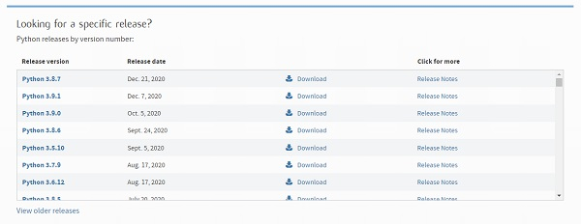

On clicking download, various available executable installers shall be visible with different operating system specifications. Choose the installer which suits your system operating system and download the instlaller. Let suppose, we select the Windows installer(64 bits).

The download size is less than 30MB.

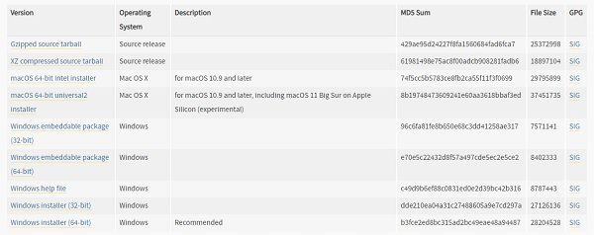

## Step 3 − Run Executable Installer

We downloaded the Python 3.9.1 Windows 64 bit installer.

Run the installer. Make sure to select both the checkboxes at the bottom and then click Install New.



On clicking the Install Now, The installation process starts.

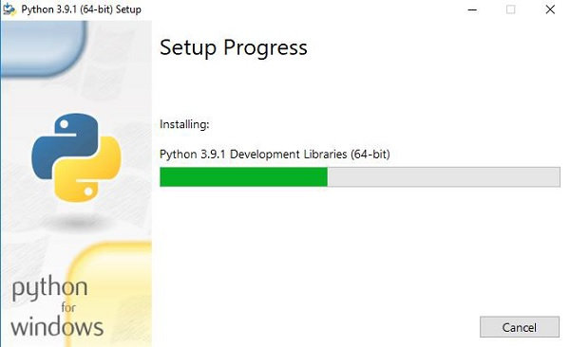

The installation process will take few minutes to complete and once the installation is successful, the following screen is displayed.

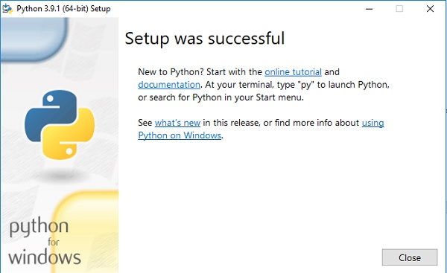

## Step 4 − Verify Python is installed on Windows

To ensure if Python is succesfully installed on your system. Follow the given steps −

* Open the command prompt.
* Type ‘python’ and press enter.
* The version of the python which you have installed will be displayed if the python is successfully installed on your windows.

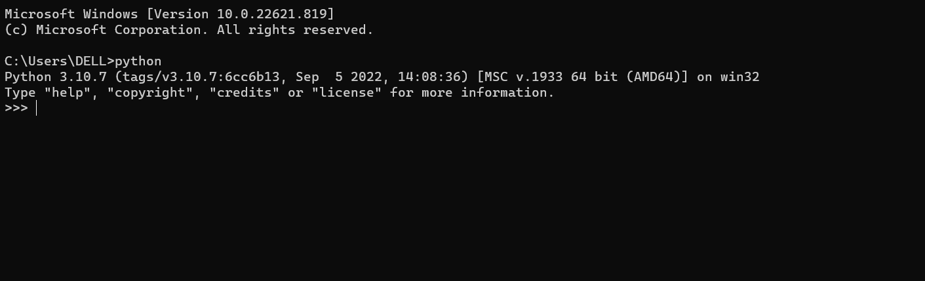

## Step 5 − Verify Pip was installed

Pip is a powerful package management system for Python software packages. Thus, make sure that you have it installed.

To verify if pip was installed, follow the given steps −

* Open the command prompt.
* Enter pip –V to check if pip was installed.
* The following output appears if pip is installed successfully.

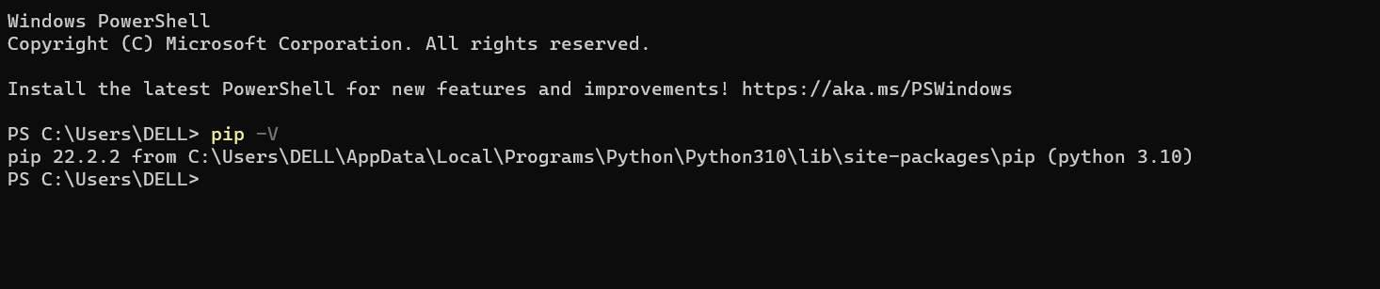

We have successfully installed python and pip on our Windows system.

**Installing Jupyter Notebook using pip command:**

PIP stands for the package management system which is used to install and manage software packages/libraries. These libraries and the packages are written in Python. These files are stored in a large “on-line repository” termed as Python Package Index (PyPI). pip uses PyPI as the default source for packages and their dependencies.

**Command to install Jupyter:**

python -m pip install jupyter

**Launching Jupyter:**

jupyter notebook

**The following window will open in your default browser**

**